You have likely heard a lot about renewable energy. You may have heard about local projects or national debates. There is a lot to understand about the pros and cons of different renewable energy sources. Opinions often color these topics as well. It is important to consider the background, motives, and presentation styles of different sources. Thinking this through helps you separate facts from opinions.

In our work today, we will explore the topic of solar energy. This is a smaller topic than renewable energy, but it still allows us to explore related issues. We will consider economics, sustainability, and other global issues.

With a group, choose one of the following short readings to complete. When you have finished, discuss what you read and what parts you believe or what parts you question. Your group should then identify the message you take away from the reading. You will communicate that idea in the form of a children's picture book.

Topic 1: Solar Panels and Sustainability https://cemastprojects.org/sf68/panels.pdf
Topic 2: How Chile’s Energy Future Affects Yours https://cemastprojects.org/sf68/chile.pdf
Topic 3: Datacenters Powered by Renewable Energy https://cemastprojects.org/sf68/data.pdf
Topic 4: Tax Credits for Renewable Energy https://cemastprojects.org/sf68/tax.pdf
Topic 5: Return on Investment for Solar Energy https://cemastprojects.org/sf68/roi.pdf

On a large piece of paper, create a single image. The image should describe your takeaway from the reading. Other than real-world labels (e.g., a sign on a grocery store), avoid using words in your drawing.

On a second piece of paper, write a single sentence which could appear next to your image in the picture book. Your class will then work together to combine each of the readings' big ideas into a single story.

Effect of Latitude on Solar Output
The Solar Farm Simulator models the sun’s position relative to Earth. The sun’s position affects climates everywhere! The climate at the equator is very different from the climate at the poles. Even at smaller extremes, the effect is evident.

Let’s look at the difference between Illinois' northern and southern extremes. Chicago is on the northern end of Illinois. At 42° N, it has a similar latitude to Detroit, Michigan and Barcelona, Spain. Cairo is a city on the far south end of Illinois. At 37° N, it has similar latitude to Las Vegas, Nevada and Athens, Greece.

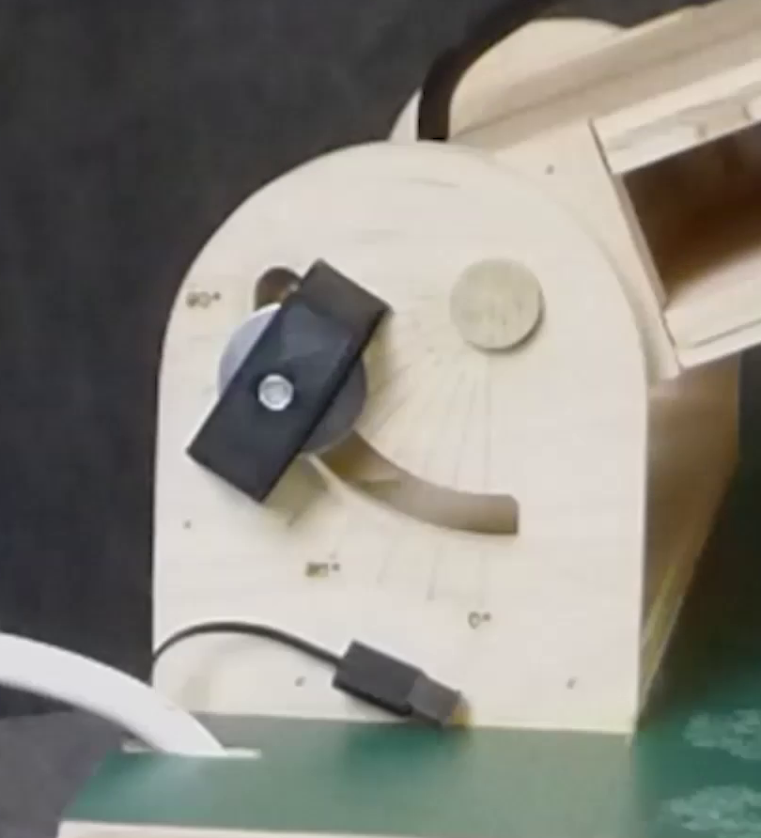
To compare these two latitudes, you will collect data on the same day. First, set the angle on the small base protractor. The small base protractor reflects both latitude and time of year.

Loosen the black knob on both sides of the base. Then, tilt the protractor to 50° and re-tighten the knobs. The angle on this small base protractor represents a day in late February at a latitude of 42°.

Next, loosen the knobs holding the big arm protractor and swing it so the arm lines up with sunrise (0°). Re-tighten the knobs. This big arm protractor angle represents time of day.

To collect data on incoming sunlight, you will need to position and connect your solar array. Put one solar array on the base. It can be at any location, in any compass orientation, and at any angle. Once you have started to collect data, DO NOT MOVE the solar array. Doing so will make your data impossible to interpret. The solar array has two wires connected to alligator clips. Hook each wire of the solar array to the leads of the multimeter. Turn the multimeter dial to 20 V (Volts DC). Finally, turn the sun on.

Check that the big arm protractor is at 0° and record the voltage. Move the big arm protractor to 30° and record the new voltage. Keep moving the arm until you have completed the first column. To collect data at the lower latitude, subtract 5° from the small base protractor. Reposition it. This change models a different latitude on the same day. Start the big arm protractor back at 0° and continue taking readings.

Big Arm Protractor | Voltage at  42°N Latitude | Voltage at  37°N Latitude
0°
~7:00 AM
30°
~9:10 AM
60°
~11:20 AM
90°
~1:30 PM
120°
~2:40 PM
150°
~4:50 PM
180°
~6:00 PM
In our model, the Earth is the stationary base, and the sun moves on a long arm. What is inaccurate about this model? Which aspects of the model ARE accurate?

What did changing the small base protractor represent?

Create a line graph of your data. Remember to include a graph title, axis titles, and a legend. Use units when needed. Place both data sets on one graph. Make the data set at 42° N latitude a different color than the data set at 37° N.

What general patterns can you see from your graph?

Why was it important not to change where the solar array was when you were collecting data?

Based on your graph, which latitudes can collect more solar energy?

Effect of Seasons on Solar Output
Illinois residents experience differences in sunlight as the seasons change. The Solar Farm Simulator's base protractor models both the latitude and time of year. In this section, we are going to set the latitude at Springfield, IL. Springfield has a similar latitude to Indianapolis, IN or Madrid, Spain. When you change the small base protractor, you will be changing the day of the year.

Change the small base protractor to 63°. Rotate the big arm protractor to 53°. Pick one solar array and place it on the base. It does not matter where you put it or the angle of the array, but DO NOT MOVE it once you start to collect data. Hook up the multimeter to the array and set the dial to 20 V (Volts DC). Record the voltage in the data table provided.

Move the big arm protractor while keeping the small base protractor angle the same. Finish collecting data in one row of the table. Next, change the small base protractor and take more measurements. Keep collecting data until the table is complete.

Angle of Sun from Horizon | Small Base Protractor Angle | Voltage at 7:00 AM | Voltage at 10:00 AM | Voltage at 1:00 PM | Voltage at 4:00 PM | Voltage at 7:00 PM
26° | 64° | < 0° | 53° | 111° | 169° | > 180°
50° | 40° | 4° | 49° | 94° | 139° | > 180°
73° | 17° | 19° | 55° | 91° | 127° | 163°
When working with this model of the Earth and sun, the telescopic arm represents the sun. This model is not completely accurate because the sun does not move around the Earth. Instead, the model shows us the sun’s position as we see it in the sky.

There were some data points where the sun was not visible to us, either before sunrise or after sunset. At those points, you still measured a voltage indicating there was some energy output. Why? What does that say about the rest of your data points?

Each row of your data table corresponds to the solstices and equinox at a given latitude. Which row of data do you think corresponds to the summer solstice? What makes you say this?

What seasons correspond to the other rows in your data table?

Make one line graph to show the voltage output over the course of a day for each of the three seasons. Remember to use graph titles, axis labels, and a legend, with units when appropriate. Make each season a distinct color so you can tell them apart on your graph.

What conclusion can you draw from your graph? What season generates the most energy from a solar array? Will this be true at every latitude?

Do small changes in latitude or season have the greater effect on voltage output of the solar array? How do you know?

Where Does Solar Energy Work Best?
As you saw earlier, solar arrays can collect more energy at lower latitudes. You were working with two locations in the Northern Hemisphere. Let’s think more globally to generalize where solar energy might work best.

Below are six global solar insolation maps from NASA. Solar insolation is a term for incoming solar radiation. The areas that are white receive the most insolation. The areas that are dark red receive the least. Each map shows the average insolation across the globe each month.

January | March
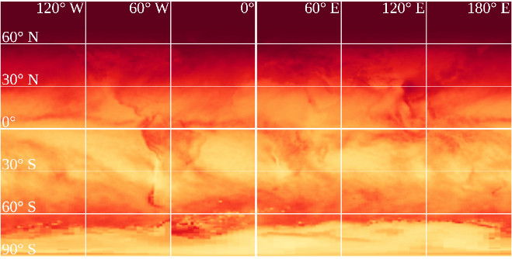 | 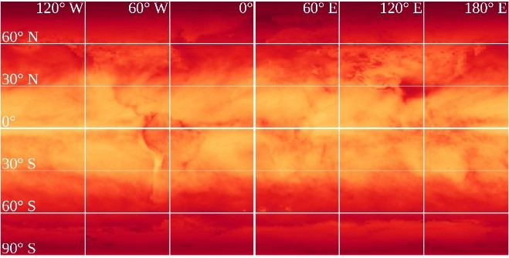
May | July
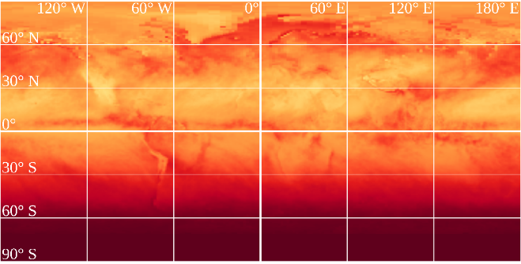 | 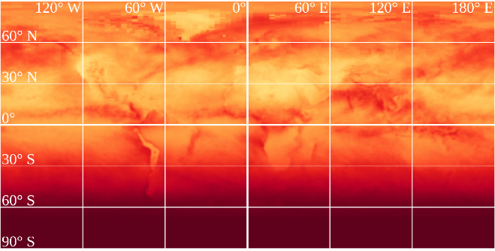
September | November
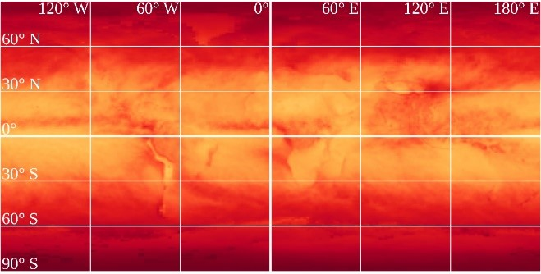 | 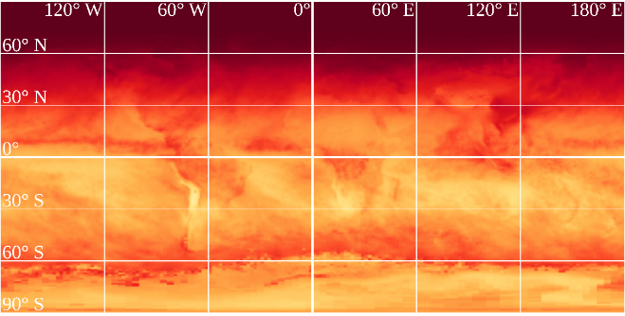

Look at all 6 maps. Which area of the globe receives the most solar insolation?

Look at January and compare it to July. Which seasons do the Northern Hemisphere have during those months? Does the map's data match your experiences of those seasons?

Does the data you collected on different latitudes and seasons fit with these models? Why or why not?

PVWatts (https://pvwatts.nrel.gov/pvwatts.php) is a tool from the US National Renewable Energy Laboratory that can tell us the solar radiation at any location in the world. To use PVWatts, type in the name of your hometown and click “Go”. Verify the map is showing the city you typed. Click the orange arrow above “Go to system details”. Leave the default values and click the orange arrow above “Go to PVWatts results.”

The results page displays monthly and yearly solar radiation values. Let's focus on the annual solar radiation. For Chicago, this is 4.55 kWh/m2 per day. Add a dot to the map to show where your hometown is located. Then, write down the annual solar radiation you found on PVWatts.

To look at your next location, click “Change Location” at the top and go through these steps again. Write each annual solar radiation value on the map.
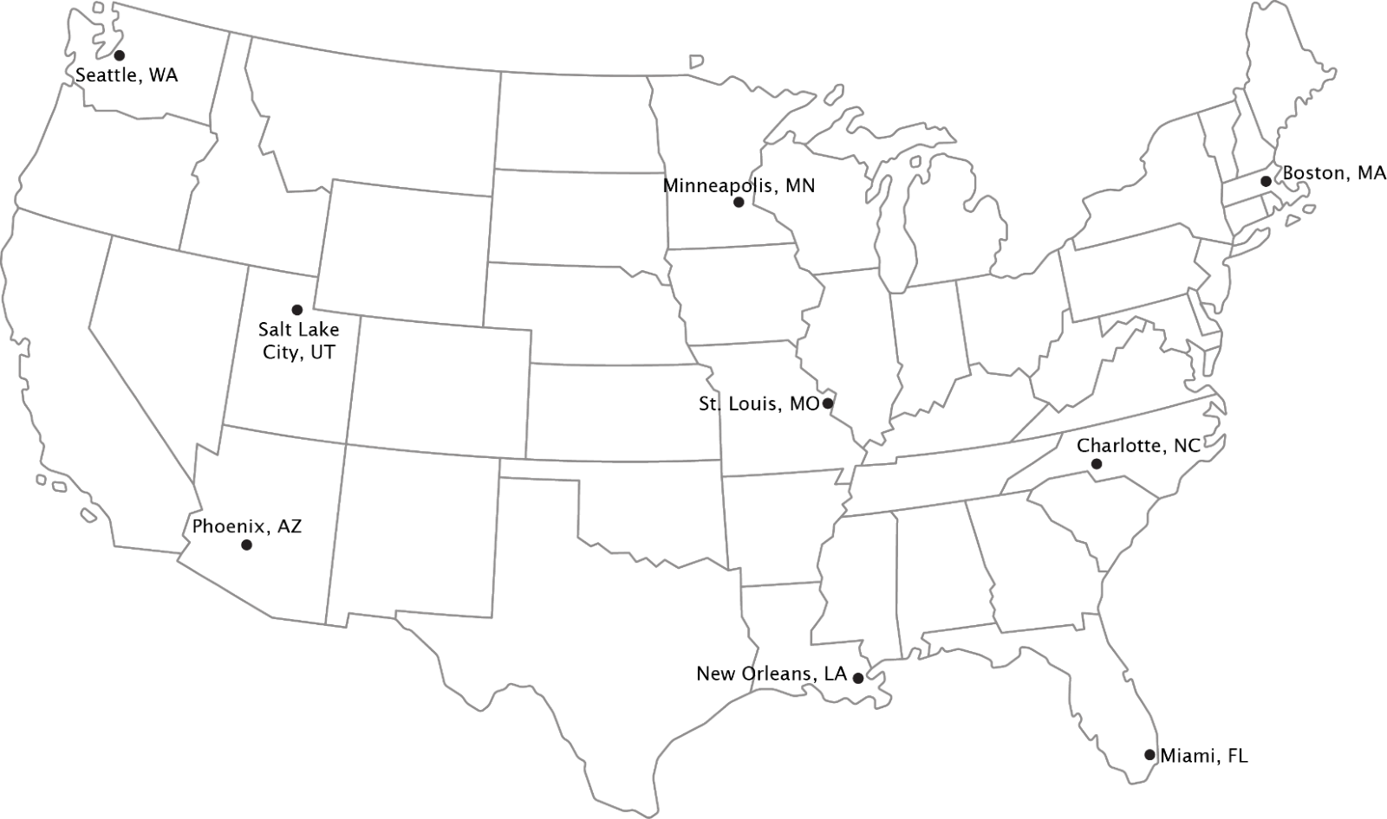
What patterns do you notice in your data? What area of the US has the highest annual solar radiation?

How promising does solar energy look for your area?

Changing Solar Array Angle to Maximize Solar Output
Your hometown likely did not receive the most solar radiation on your map of cities. That’s okay. As humans, we are always changing things to make them work better. We can manipulate our solar arrays to increase solar output.

Before now, you chose how to place your solar array for data collection. This time, orient the solar array so the longer side is parallel with East and West. When you collect data, you will only be changing the angle of the solar array. The location of the solar array should not change as you collect data.

Move the small base protractor to 50°. Start with the solar array set to 0°. This is when the solar array is not tilted at all. Set the solar array so the longer side is parallel to east and west. Make sure the solar array can tilt toward the south. Move the big arm protractor so it lines up with 0°. Hook the multimeter leads to the wires on the solar array. Set the dial to measure V (Volts DC). Record your measurement.

Continue to take measurements by moving the solar array angle. When you have finished collecting data at one big arm protractor angle, move to the next. The small base protractor should remain at 50° for the entire data collection. You may need to move the wires out of the way on the solar array to adjust it all the way to 90°.

Solar Array Angle | Voltage at  ~6:45 AM  0° | Voltage at  ~8:30 AM  30° | Voltage at  ~10:15 AM  60° | Voltage at  ~12:00 PM  90°
0°
30°
60°
90°

Graph your data. Remember to include a graph title, as well as axis titles and units. Place all data sets on one graph. Make the data for each solar array angle a different color.

Look at your data table. What values would you expect when the big arm protractor is at 120°? 150°? 180°?

What time of year did we measure data for? How do you think your solar array angle would need to change to maximize voltage at other times of the year? Use the solar farm simulator to check your hypothesis.

Wrap-Up
Solar energy is a popular alternative energy source, though some areas are better for solar power than others.

We have studied the position of the panel and the position of the sun in the sky. What are some other factors that affect solar energy capture?

Which of these factors would have the greatest impact on solar collection in your hometown?

Is your hometown a good place for solar panels? Why or why not?

Even if your hometown is not the ideal place for solar panels today, that may change tomorrow. Solar panels get better every year. Today, the average solar panel can capture about 20% of the sunlight that reaches it. Every year, panel efficiency increases by about half a percent. That may seem small, but it adds up quickly!

Other changes in technology like tracking systems and bifacial panels can also increase efficiency. Tracking systems use motors to change panel angle as the sun moves in the sky. In solar farms, bifacial panels use two-sided solar panels to collect more energy.

Solar power is a technology worth tracking!

