Nearly everything requires some type of energy. Of course moving a car or bus, manufacturing products, and constructing buildings require energy, but the "little things" like heating your food and charging your cell phone also require energy. Energy allows things to be done. Imagine what would happen if electricity was shut off at your school. We are all very dependent on reliable energy!

Nearly all work was done by muscle power until about 200 years ago. Using animals helped make work easier and more efficient, but both humans and animals have very little power and get tired quickly.
Inventors have always been looking for ways to produce power that are reliable and inexpensive. Around 200 B.C.E. Europeans were using waterwheels to crush grain, saw wood, and do many more tasks. In 1000 A.D., the Dutch had harnessed the power of wind to do many of the same tasks as well as to pump water.

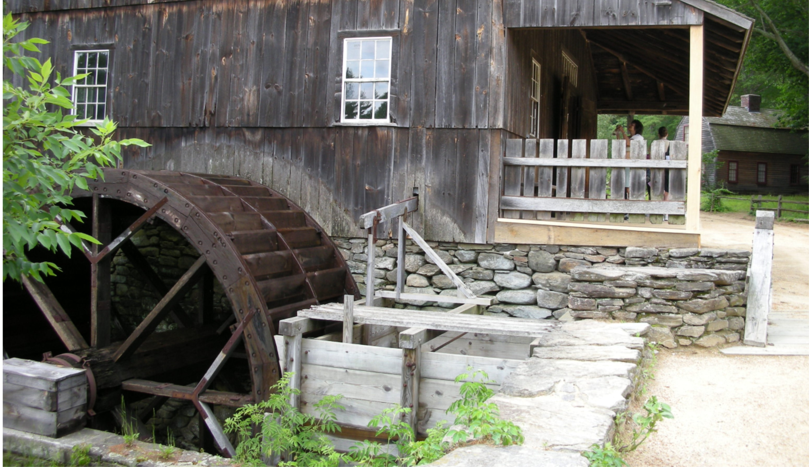

Steam Power (1769-1820): Exploration

Wind and water are unpredictable, however, so other sources of energy were sought. In 1769 James Watt, a Scottish engineer, patented the modern day steam engine. Steam engines quickly replaced less reliable sources of power.
How do you think a steam engine works?

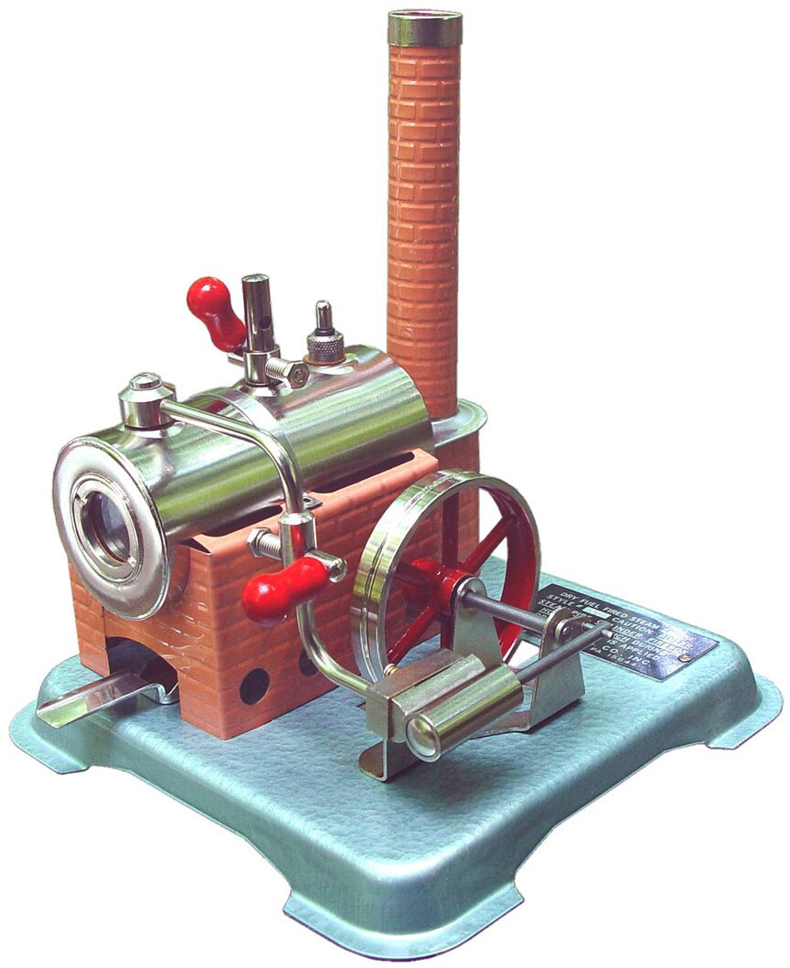

Your teacher will set up a steam engine and provide it with fuel.
Record what happens as the engine begins to run.

A steam engine provides great power to get work done, but only in a mechanical form—it must create motion. Factories using steam power in the 1800s transferred its mechanical motion using long shafts with many pulleys and gears. Imagine how dangerous it would be to work in this factory!

The shafts, belts, and pulleys which transferred power from a steam generator to factory machinery can all be seen in this textile factory.

Steam Power (1769-1820): Discussion

What happens to the water as the fuel burns?

What is the source of energy for this steam engine?

Energy can be classified into many forms including thermal (heat) energy, chemical (stored) energy, mechanical energy (energy of motion), and/or electrical energy. What are the energy transformations you have seen in the steam engine?
_____________ energy > _____________ energy > ___________________

Linking Magnetism to Electricity (1820-1831): Exploration

In 1820, Dane Hans Christian Oersted found that his compass needle moved when placed near a wire connected to a battery. A few years later, Frenchman Andre-Marie Ampere discovered that two wires with energy running in different directions could attract and repel one another, just like magnets. A decade later, Englishman Michael Faraday figured out that magnetism makes electricity and electricity makes magnetism.

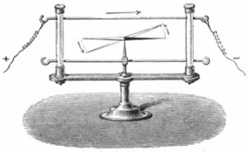

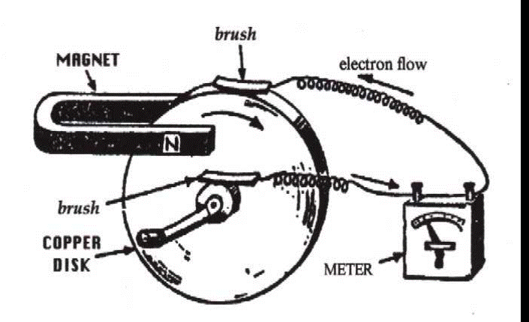

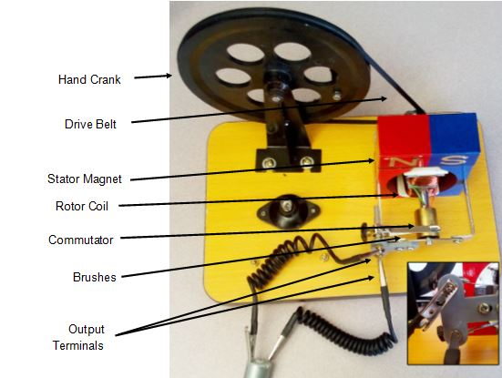

Without the motor or lamp connected, turn the hand-crank generator.
What part(s) of the generator spin, and what part(s) stay in place?

Use the cables with alligator clips to connect the two little metal tabs on the back of the motor to the two output terminals on the generator. It does not matter which ones are connected. Fold a small piece of tape around the motor shaft so you can easily see it spin.

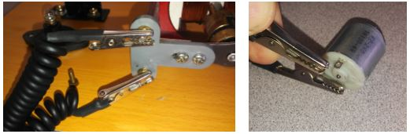

Have each person on your team take a turn on the hand crank.
What do you observe happening as you turn the crank?

Disconnect the wires and set the generator aside.

Linking Magnetism to Electricity (1820-1831): Discussion

Explain how you think the generator is producing electricity.

How does electricity get from the generator to the motor?

Trace the transfer of energy from the generator to the motor, using the terms thermal (heat) energy, chemical (stored) energy, mechanical energy (energy of motion), and/or electrical energy.
___________________ > ___________________ > ___________________

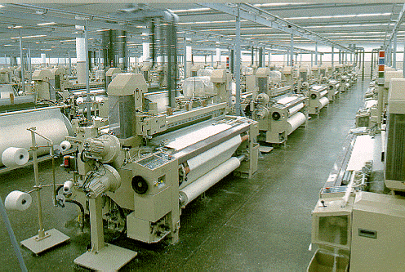
An electric loom uses a centralized motor, so any belts or shafts can be contained within the machine to keep workers safer.

Michael Faraday made a machine that spun a copper disc inside a magnetic field. He called it a "dynamo." Electric generators convert mechanical energy (energy of motion) into electrical energy.
By the 1850s inventors were attaching dynamos to steam engines. They burned coal to heat water into steam. The steam spun a shaft that was attached to the rotor of the generator. We still use coal-fired steam powered dynamos today to generate electricity.
One of the earliest uses of electricity was the electrical motor, developed by Prussian Moritz Jacobi in 1834.

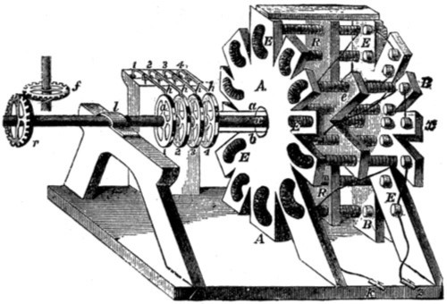

It did not take long before factory owners realized that the electric motor was much better than the huge shafts, pulleys, and belts that were powering their machinery. Electric motor technology improved rapidly and many machines were converted to run on electricity. This posed a problem, however. There were no power plants producing electricity. Many factories built their own power plants right next to the factory building.

New Skills for Electricity (1825-present): Exploration

Inventors soon learned that working with electricity required a new set of skills. They had to learn how to cut and strip wires and hook up circuits. They also had a lot to learn about safety.
Wires are pipes for electricity, just like hoses carry water. Similar to hoses, the plastic around the wire keeps the electricity from leaking out. Without the coating, the electricity could follow the incorrect path.
A circuit is a complete path for the electricity to follow. It basically has to have a way from the generator (or battery) to the electrical device and a way back to the generator. Think of it as water flowing through a pipe with one major difference: if a water hose is cut, water leaks out. If a wire is cut, electricity stops immediately because it no longer has a way to get back to the generator.
If electricity is allowed to flow through the circuit with nothing to slow it down, such as a light or motor, the wire will get hot and probably start a fire. This is called a "direct short." That is why it is so important that the wrong wires do not touch each other.
Electricians use different colors of wire to ensure they don't connect the wrong ones together. There is some variation across the country in which colors are used for what applications, but there are general rules.
Red, black, blue, and sometimes yellow wires are used for power. They are considered the "hot" wires. In this Smart Grid Construction Set, connect the red, blue, or black wires only to springs.
White and green wires are used for "common" or "ground." In this system, these wires connect to the alligator clips. NEVER connect a white wire to a spring.
If you make a mistake and connect a spring to an alligator clip, there will be a direct short. To keep the wires from getting hot and possibly starting a fire, the power plants all have fuses. If there is too much electricity flowing in the wire, the fuse will "burn" and shut off the power. Show your teacher how you fixed the problem and then ask them to replace the fuse.
Your home has circuit breakers for protection. Perhaps you have plugged in or turned on too many devices in your home and "blew the fuse" or "tripped" the circuit breaker.

You will be hooking up many wires. You will need to cut them to the correct length and strip the insulation off both ends using a wire cutter/stripper.

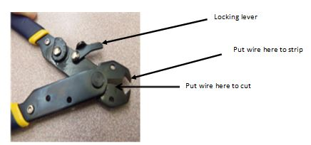

Adjust the cutter to strip the wire by turning the little dial on the side. It should be set on 20. This dial keeps the jaws open just enough so the V-shaped part will cut through the plastic coating but not through the wire itself. You can use a small piece of tape to help keep the dial set.

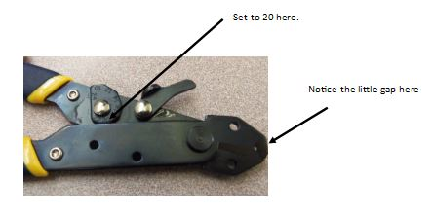

Your wire tool might look like this:

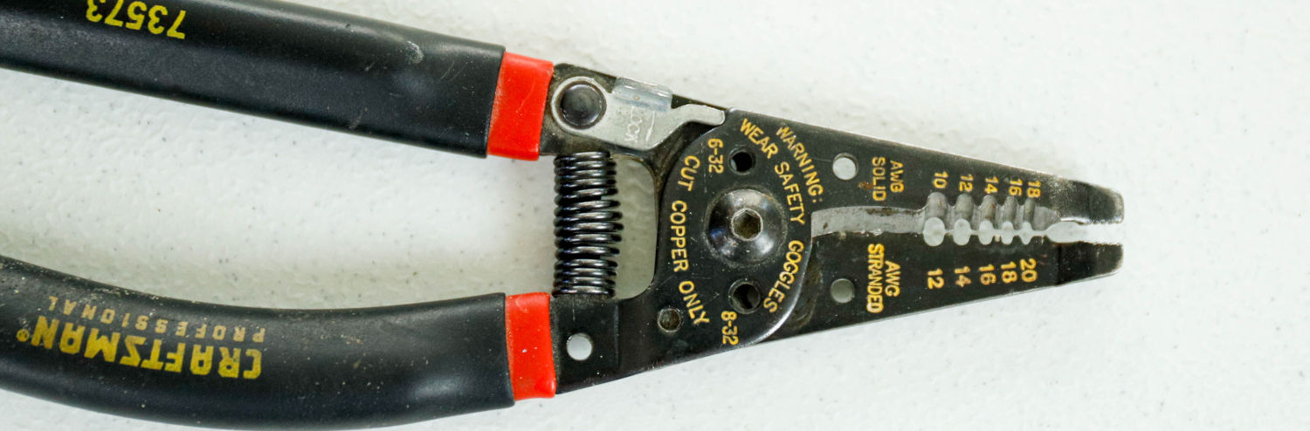

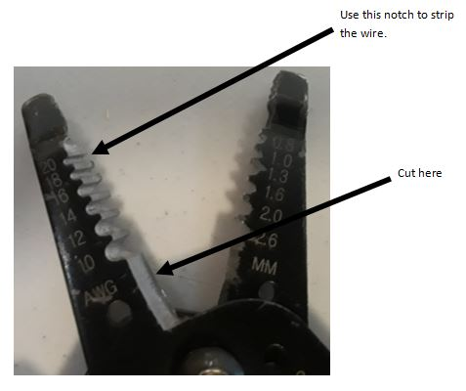

Measure the right length of wire by holding it between the two connections. A bit too long is better than a bit too short.
Before cutting, check that you are using the correct wire colors (white on alligator clips only!).
Cut it to the right length using the cutter blade on the wire tool.
Strip about 1/2 inch (about 1 cm) of plastic insulation off both ends of the wire.

To connect up a wire, simply bend the spring to the side (or on a distribution pole, pull it down) and stick the bare end of the wire between the spring coils. Be sure the spring is touching the bare end of the wire and not the plastic insulator. To insert a second wire into the same spring, bend it the other direction so the spring pinches the first one in while you insert the second.
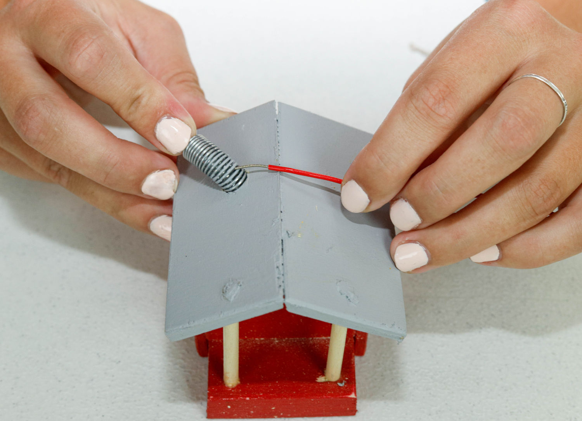

New Skills for Electricity (1825-present): Discussion

What is a circuit?

What is a direct short?

How do electricians know what wires to hook together and which ones can never be connected?

Can a black or red wire ever be connected to a white or green wire? Why or why not?

What happens if a wire carries too much electricity?

What device keeps the wires from getting hot and possibly starting a fire in your home?

Electrical Power (1830-1880): Exploration

New technology is always expensive so the people who use it first are usually those who use it for profit rather than convenience. Factory owners found that electric motors were more efficient, more adaptable, quieter, and safer than other forms of machinery. But, they needed electricity. They had to make their own.

Most power plants make electricity by burning fuel to turn water into steam. The steam turns a turbine that spins a generator. This really has not changed much in the past 150 years. In the 1800s, however, they used wood or coal. In Illinois we use coal and natural gas to produce a bit less than half of the electricity in Illinois. Nuclear power makes the other half. Wind power has been used to generate electricity for nearly 150 years, but it has never been a major source of power because the wind is not always blowing.

Select one of the power plants. Notice it has 3 springs on top as well as an alligator clip. All power plants produce 3-phase Alternating Current (AC). Each wire carries 1 phase. That is why most of the power lines you see have 3 (or sometimes 6) main wires.
Houses usually need only a single phase, and it does not matter which one. Factories, however, like to use 3-phase power because it makes their motors more powerful and their machines run more smoothly.

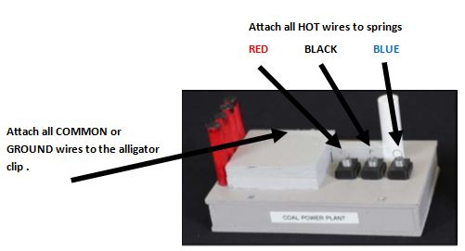

Just like 150 years ago, place the factory beside the power plant.
Measure, cut, and strip both ends of a white wire and clasp it between the alligator clips.

Measure, cut, and strip both ends of a red, black, and blue wire and connect each between a spring on the power plant and a spring on the factory.

Ask your teacher to inspect your work to make sure there are no direct shorts.
When you have permission, connect the power plant to the power company headquarters office building using a cable with 1/4" audio jack ends.

Turn on the power. What happens?

The Advent of Electrical Power (1830-1880): Discussion

Before the use of electricity, what did factories use to power their machinery?

What are some of the benefits of electric motors over other types of power?

Why did factories have to install their own generators?

Electrical Enlightenment (1880-1920): Exploration

Set out the hand-crank generator.

Connect the output terminals to the light bulb.

Each person on your team should take a turn on the hand crank.

What do you observe happening as you turn the crank? Does anything change when you turn the crank faster or slower?

Disconnect the wires and put the generator away. You will not need it again.

Until the late 1800s, electricity was only for factories and big commercial buildings. Nobody ever thought they would need it in their home. That attitude changed with the invention of the light bulb. Now with just a flip of a switch, people could have instant light. (This was far easier, safer, and brighter than lighting a candle!) Inventors started coming up with more and more appliances that could run on electricity. Soon, everybody wanted their house hooked up to the power plant.

Turn off the power to the headquarters office.

Set a house near the factory.

Measure, cut, and strip both ends of a red, black, or blue wire. Then connect the spring on the house to one of the springs on the power plant.

Measure, cut, and strip both ends of a white wire. Use this white wire to connect the alligator clip on the house to the alligator clip on the power plant.

Check your wiring for shorts.

When you are certain it is correct, turn on the power to the headquarters office.
What happens?

Electrical Enlightenment (1880-1920): Discussion

Why do you think there was a change in the light when the hand-crank generator was turned faster or slower?

How are electric lamps an improvement over candles and other lights?

Who do you suppose were the first people to get electricity in their homes? Why?

How did the electric light bulb change the way people lived?

In 1841, Frederik de Moleyns, a British physicist, patented the first electrical light bulb. Thomas Edison is better known for his work with the light bulb because he provided both bulb and power source. Edison opened his Pearl Street Station in 1882, which provided power to electric lamps in a small neighborhood in New York City. His plant served 85 customers and powered 400 light bulbs. How many light bulbs do you suppose there are in New York City today?

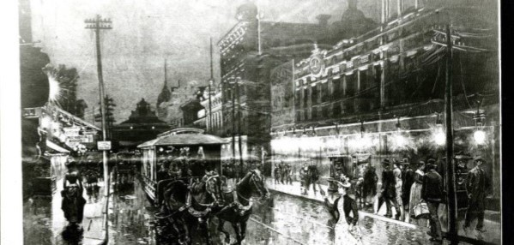

The Pearl Street Station showed the world what electricity could do. Companies immediately started building systems to get electricity to everyone. When prices came down, what had primarily been a tool for industry or a luxury for the wealthy quickly changed the lives of average Americans.

Edison's 1882 Pearl Street Station was a coal-powered plant. The first windmill used to generate electricity came soon after (in 1888) when Charles F. Brush built a turbine to power lights and motors at his home in Cleveland, OH.
While natural gas was used in different ways over time, the first natural gas power plant as we know it today was built for Oklahoma Gas and Electric in 1949.

The first nuclear and solar plants would come much later—the first nuclear power plant was built at Calder Hall in Cumbria, U.K. in 1956 and the first modern solar plant was built in the Mojave Desert in 1981.

Thomas Edison's Pearl Street Station had a major flaw. It used direct current, which can only travel short distances.
In 1886, Frank Sprague used an alternating current generator and transformer to make the first long-distance AC power transmission in Great Barrington, MA. Alternating current can travel much longer distances than direct current.
In 1895, George Westinghouse partnered with Nicola Tesla to build a water turbine at Niagara Falls. It supplied power to the town of Buffalo, NY about 20 miles away.
Unfortunately, alternating current transmission still had a flaw—the low-voltage lines lost a large amount of energy to electrical resistance. Michael Faraday had already solved this problem 50 years earlier. His early work on induction allowed Westinghouse and Tesla to increase and decrease the voltage using transformers. Higher voltages could be transmitted longer distances with less loss.

Building the Grid (1886-1900): Exploration

Unplug the thick cable to the headquarters office before changing the wires.

Disconnect any existing power lines from your power plant.

Place the power plant and headquarters office at one end of your table and set the homes, shops, factory, etc. around the edges of the table.

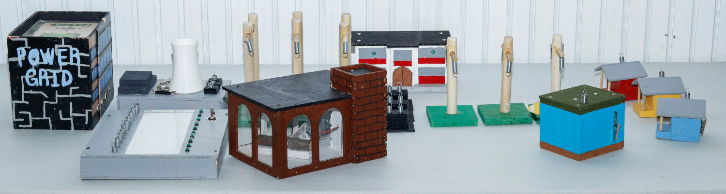

Generally, the taller the pole or the higher the wire is off the ground, the higher the voltage that the line carries. Transformers are used to change the voltage of a line. Notice that the springs on the power plant are on black transformers. They "step up" the voltage so that it can go a long distance to the customers. A substation has several transformers.

Set up several high voltage H poles in a line from the power plant to the middle of your table.

Measure, cut, and strip both ends of red, black, and blue wires and connect them from the springs on the power plant to the first high voltage pole.

Continue connecting red, black, and blue wires from one pole to the next until they connect to the factory.

Thread a white wire through the holes in the top of the H-poles to extend all the way from the factory to the power plant.
Cut this white wire to the right length and strip the ends. Connect them to the alligator clips on the factory and the power plant.

Check your wires and turn on the power. Does the factory function?

Turn off the power after testing.

Connect red, black, and blue wires to other customers that need 3-phase electricity. Simply branch off the springs on the towers.

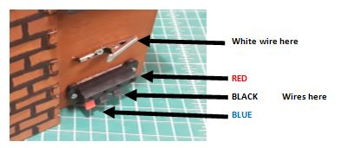

Remember that you must have a complete circuit. The electricity has to have a way to get back to the power plant. One method is to connect your white wire to an existing white wire. Cut the existing wire and strip both ends. Insert both ends and the end of your new wire into a wire nut. Twist them together with the nut.

Check the wiring and turn on the power. Turn off the power when you are done testing.

Before distributing electricity to your neighborhood, the voltage has to be "stepped down." The wires you see on your street are usually about 7,200 volts. That is still very dangerous, but not nearly as dangerous as the 120,000 volts or more in transmission lines. The 7,200 volt line is stepped down again with a bucket transformer mounted on the pole just outside your house or by the transformer inside the green box in your backyard.

Connect a red, black, or blue wire from an H pole to one side of a transformer.

Using that same color wire, connect from pole to pole to get to a house. The pole nearest the house should have a bucket transformer on it.

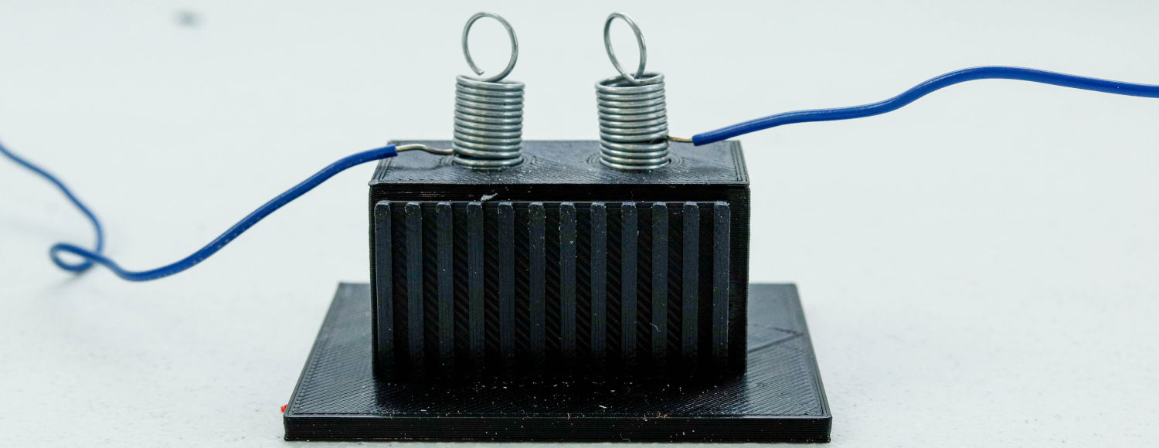

Hook up other wires and transformers to get power to every customer.

Run the white wire through the holes in the top of the poles all the way back to the power plant.

Connect the alligator clips of all of the houses and customers to the main white wire.

When you are certain everything is hooked up correctly, turn on the power.

Do all customers have power? If not, what is wrong?

Building the Grid (1886-1900): Discussion

What is the advantage of high-voltage power transmission? Why couldn't all power lines be low voltage?

What is the purpose of a substation?

Why do substations always have high fences around them?

Are there any substations, transformers mounted on poles, or "green box" transformers near your home?

Safety: Never go near a downed power line. Get away and call 911 immediately. Never do anything that might connect you to a power line. A kite string, ladder, or even digging into a buried power line with a shovel can cause severe electrical burns or death.

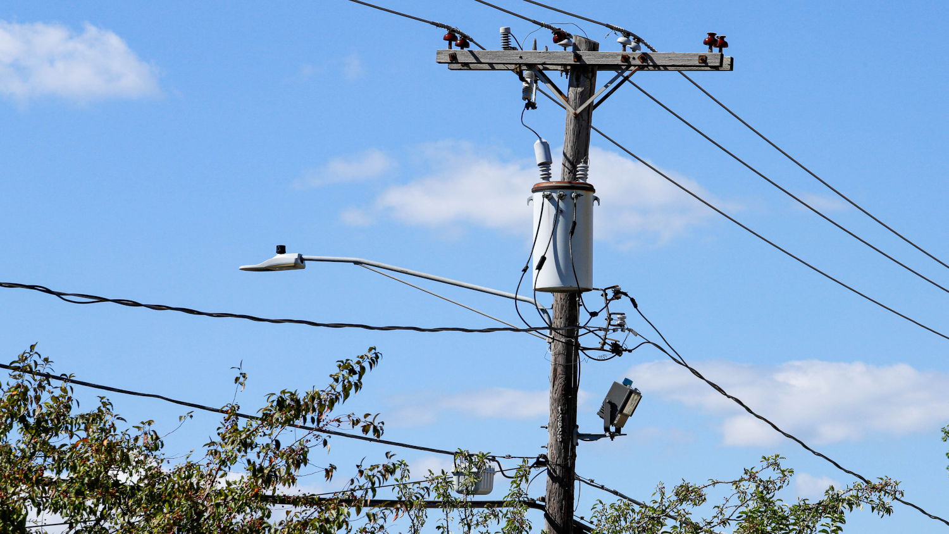

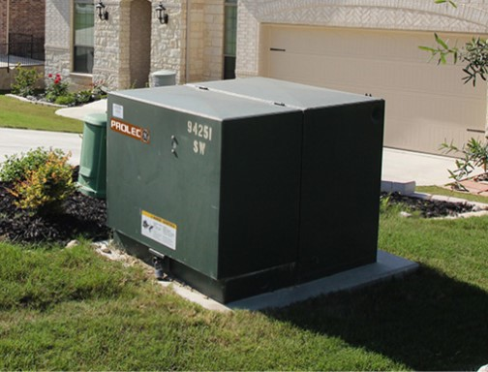

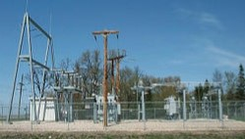

Switching the Grid (1900-1950): Exploration

As more and more customers were connected to the grid, a system had to be developed to shut off power to some locations and redirect it from others. Switches were installed at various places in the grid to control the flow of electricity.

Switches are always found at the substations with the transformers. They can also be found on many poles.

To hook up a switch, strip the ends of the wires and bend the bare wire around the screws. Tighten the screws to hold the wires in place.

Put several switches into your grid so that some circuits can be turned off while others stay on.

The switches ALWAYS go on the hot wire (red, black, or blue) and NEVER on the ground or common wire (white or green).

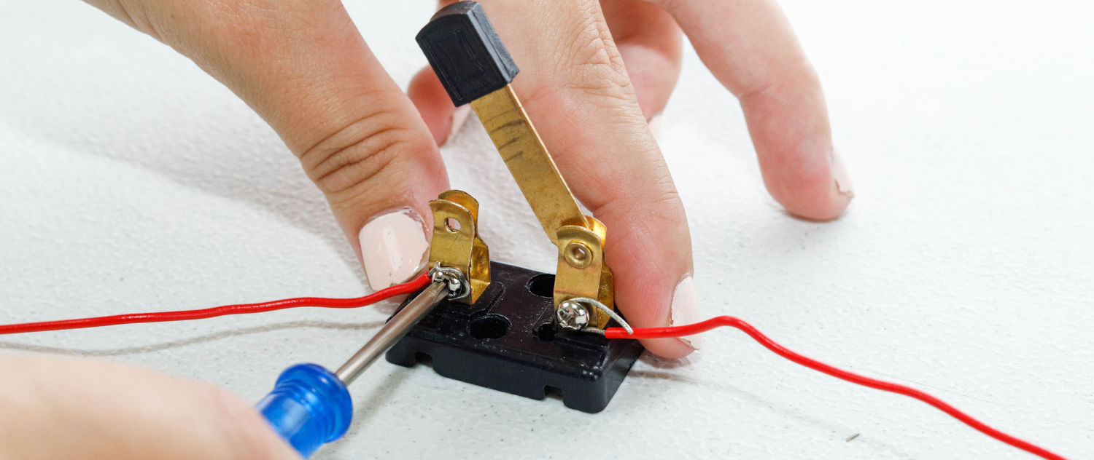

Switching the Grid (1900-1950): Discussion

What does a switch do?

Why is it important to have lots of switches in the grid?

How did the installation of switches promote safety and lead to fewer accidents?

The first long-distance high-voltage transmission line was established in 1917, carrying power from a steam plant at a coal mine to the city of Canton, OH 55 miles away. The ability to transmit energy efficiently over long distances transformed the way power companies began to operate—the Canton plant virtually eliminated the expensive transportation of coal since the power plant and coal mine were located in the same place!
Transporting electrical power over long distances, however, introduces another new problem: if a customer lost power, there was a much longer line to inspect for problems. You have probably already experienced how hard it can be to find a problem in your grid. As multiple power plants and multiple grids were interconnected, the grid gets larger and more complex, making it very difficult to pin-point a problem and fix it quickly. A smarter system was needed. Electricians added sensors to key locations to monitor electrical power.

Monitoring the Grid (1950-present): Exploration

Devices have been used to monitor the flow of electricity in the grid for decades. Since they were rather expensive, only a few were installed. As technology had advanced, these sensors and monitors have become more and more "smart," leading to the development of the "smart grid."

Connect a 1/4" audio cable from the headquarters office to your smart grid monitor.

Use a grey wire to connect from the top spring on the monitor to any spring on your grid.

Record the number for this location on the panel using a dry erase marker.

What happens when you connect this wire? What does the smart grid monitor tell you?

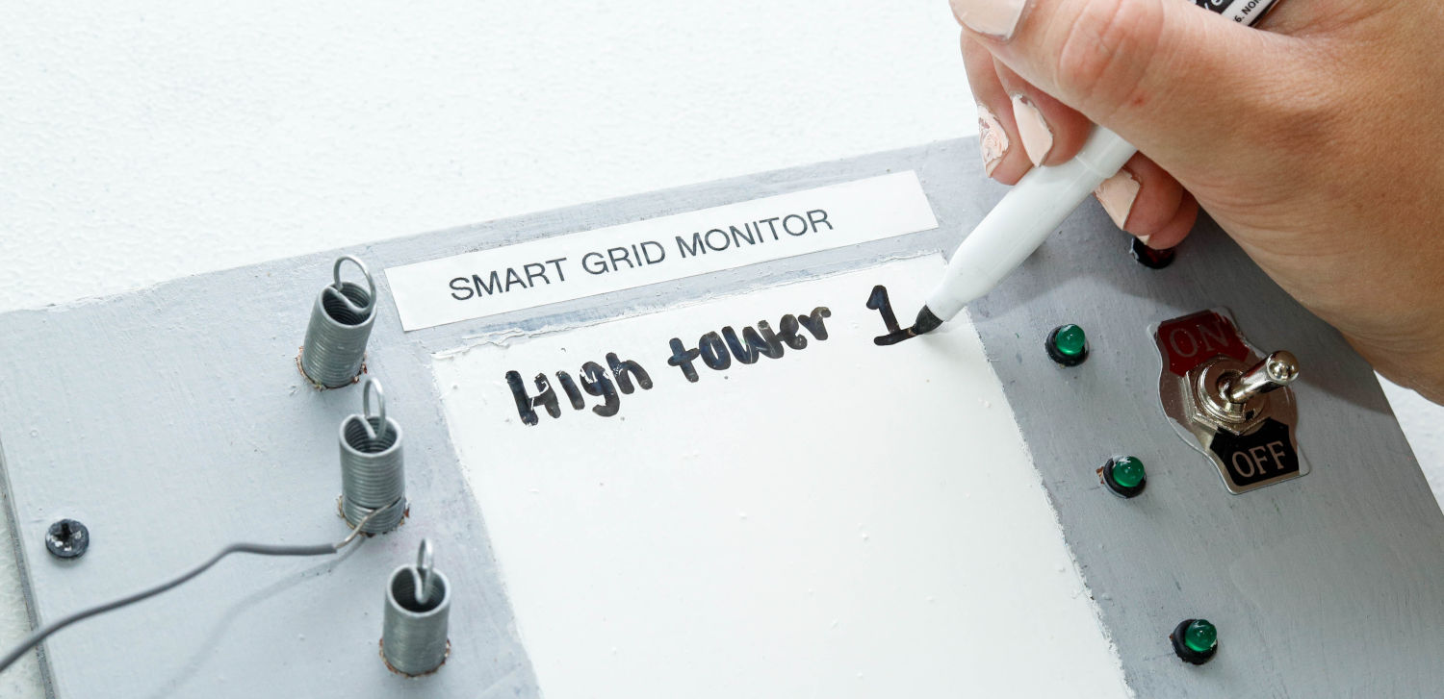

Repeat the instructions above to connect grey wires to 4 main locations throughout your grid.

Since you only have a few sensors, where should you put them?

Have a team member disconnect a wire from somewhere in the middle of your grid while everyone else watches the smart grid monitor.
Did any of the sensor lights turn off? Why or why not?

Have a team member disconnect a second wire from somewhere else in your grid while everyone else watches the smart grid monitor. Instead of fixing the problem, use your monitor and switches to reroute the electrical power around the problem to the affected customers. You may need to move some sensors and switches.

Monitoring the Grid (1950-present): Discussion

How did you decide where to put your sensors?

How did these sensors help you find problems?

How could the monitor system be improved to find problems more accurately?

Because sensors were expensive, they were reserved for important locations and the "big" customers (like factories and commercial buildings). They were not installed on homes. How did the power company know if the electricity went off at a house?

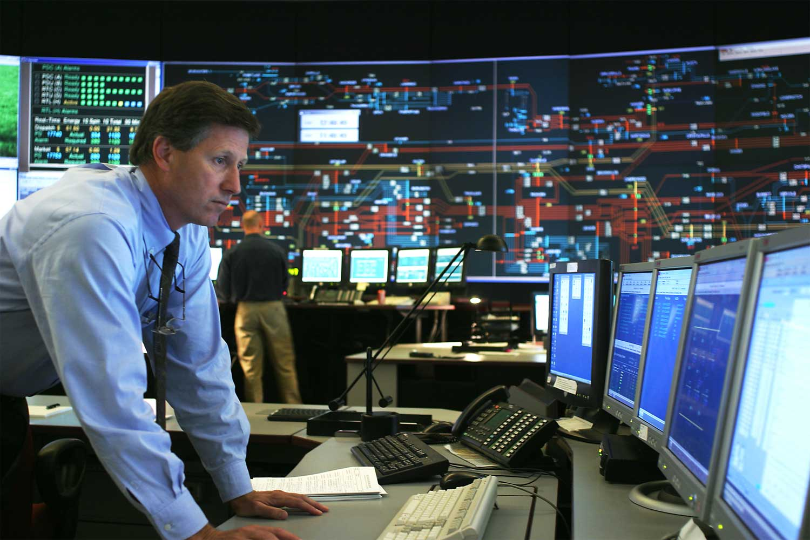

In 1953, American Electric Power built a seven-state interconnected grid to share power. With the grid, if a power plant stopped working, others could generate more to keep the power on. This required a lot of switches.

The Grid Grows (1950-today): Exploration

Unplug the thick cable to the headquarters office before changing the wires.

Move your entire table (your entire grid) so it is alongside at least one other group.

Working with the other group, figure out a way to use switches to control how power from either one of the power plants can reach your customers.

How do you need to change your grid to have a switch control which power plants provide power?

How do you need to change your grid to have a switch control which neighborhoods and customers receive power?

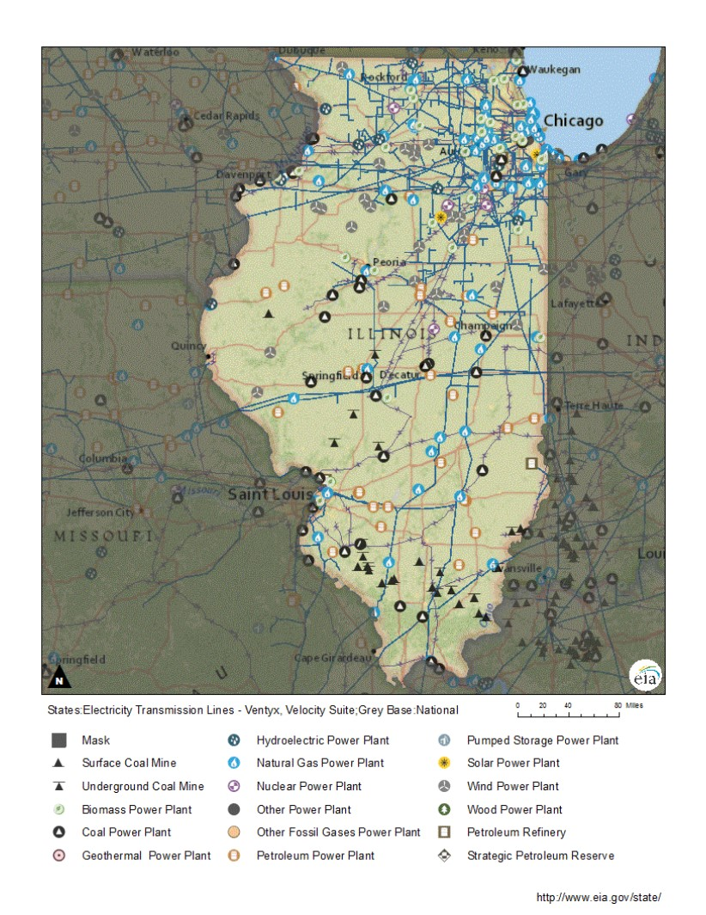

The Grid Grows (1950-today): Discussion

Why is it a good idea to have the grids of cities, states, and entire regions interconnected?

How did switches help your customers?

How do your sensors help control the grid and locate problems?

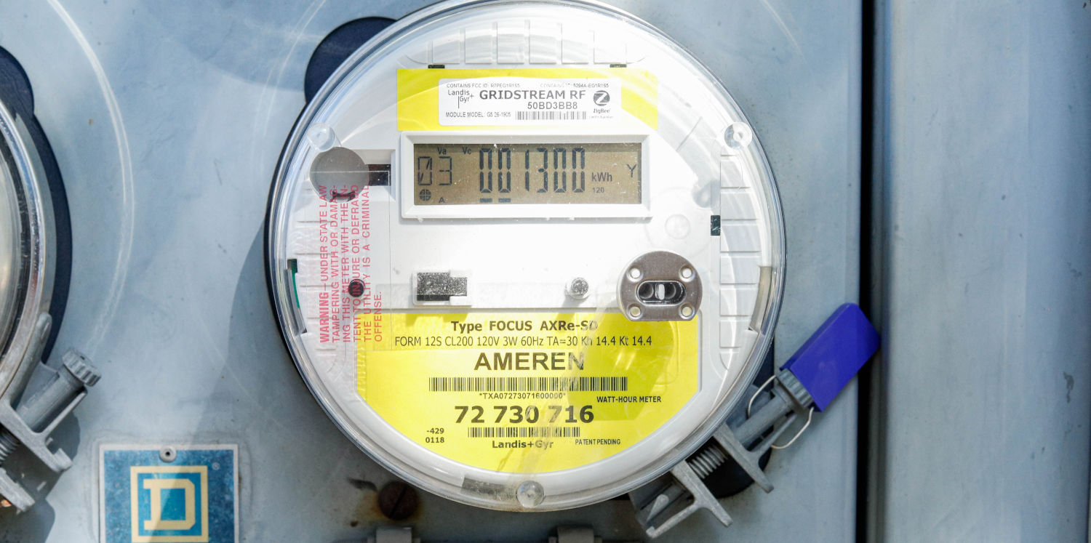

Making the Grid Smart (2000-2020): Exploration

Place smart sensors wherever you need them throughout your entire grid. Be sure to label them on your monitor.

Disconnect power lines to see if you can use your smart grid monitor to quickly find problems.

One of the main advantages of a smart grid system is that the sensors control the switches. When a problem is detected by smart grid sensors, switches are automatically opened or closed at various locations throughout the grid to route power around the problem.
A smart meter on a house is a sensor that is in two-way communication with the power company. All smart meters transmit data about power use and receive commands that adjust the circuits to assure that all homes have enough power. If a smart meter has not yet been installed on your home, it will be soon.

Making the Grid Smart (2000-2020): Discussion

How did you decide where to put the sensors?

What can you do with lots of sensors that you cannot do with only a few?

List some of the advantages of allowing the sensors to automatically control the switches.

Explain why is it is a good idea for power companies to put smart meters on all homes in Illinois.

You have now built a very large and complex grid system with lots of power plants, substations, and customers, but this is still a simple representation of the actual grid.
Although the grid is large and complex, it is still based on 100-year-old technology. If Edison, Westinghouse, and Tesla were alive today, they would recognize our current system.
It works well now, but it may struggle to meet future demands. For example, nearly all cars are currently powered by gasoline. As electric cars become more prevalent, the energy to move them will be purchased from the electrical grid, not the gas station. This alone could greatly increase electricity demand.
The smart grid is one big step towards managing electrical production and consumption, making our system much more efficient.

Follow-Up Discussion Questions

There were four different power plants available: coal, natural gas, nuclear, and renewable energy (either solar or wind power). What is the difference between these plants?

How do the different power plants impact the environment?
Coal:
Natural Gas:
Nuclear:
Renewable:

Government initiatives are spurring investment in solar and wind energy. How is this beneficial?

Why would some people suggest that natural gas is a better investment than in solar or wind?

If your school were to install a way to generate its own power, which method should they purchase? Why?

Suggest some ways that you could reduce energy consumption.

There are some people opposed to the installation of smart meters on their homes. What reasons are given? Are their reasons valid?

Describe your vision for the future of electricity.

