Look around the room for things that run on electricity.
How do we make electricity?
How does it get to your school?
Let's find out!

Steam Power (1769-1820): Exploration

About 250 years ago James Watt invented the steam engine. How do you think a steam engine works?

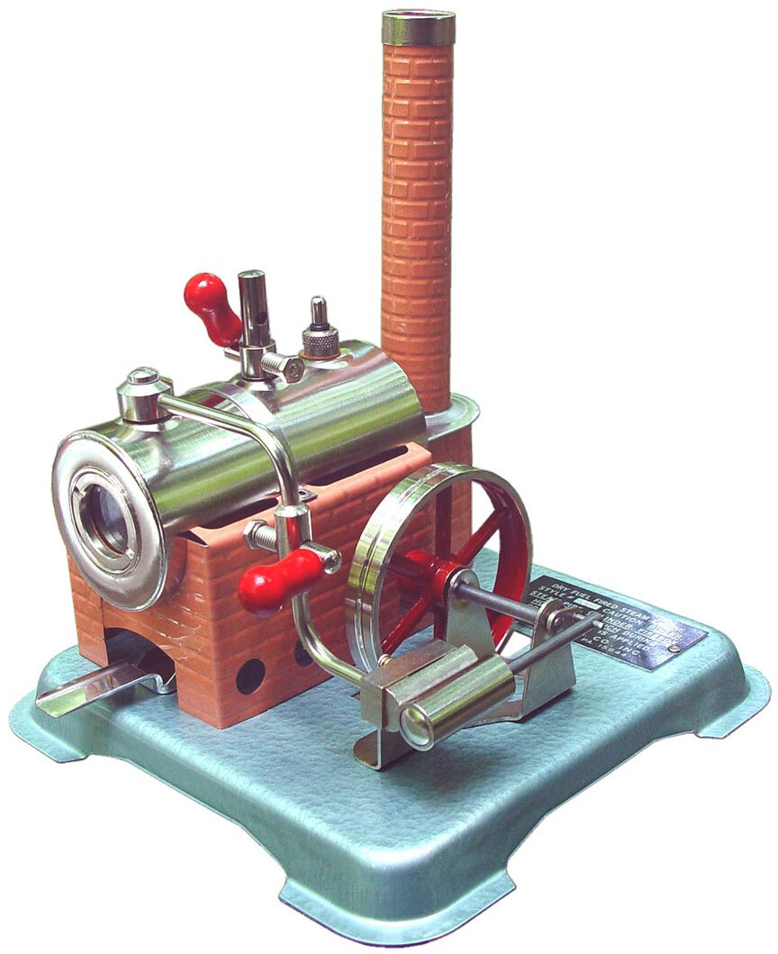

Your teacher will run the steam engine. Watch what happens.
Can you explain how it works?

Steam Power (1769-1820): Discussion

What happens to the water as the fuel burns?

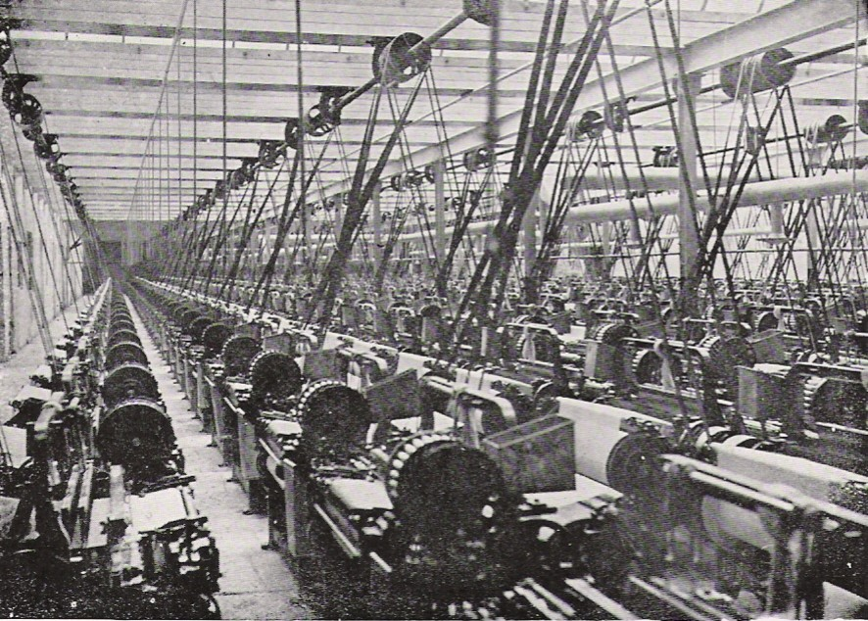

This is an old factory powered by a steam engine. Would you want to work in this factory? Why or why not?

Why were steam engines better than wind or water power?

Linking Magnetism to Electricity (1820-1831): Exploration

Mr. Ampere used electricity to make magnets in 1827. In 1831 Michael Faraday used magnets to make electricity.

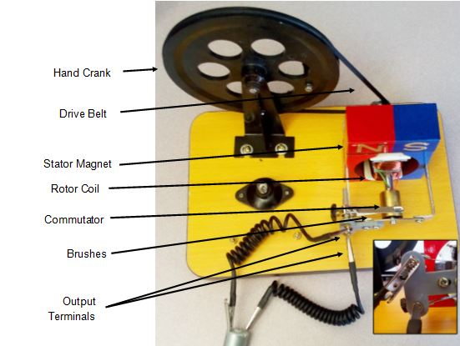

Turn the crank on the generator. What part spins most and what parts do not move at all?

Connect two wires from the generator to the motor.

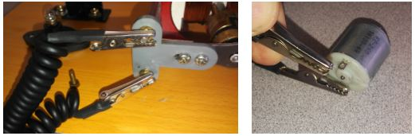

Turn the crank. What happens?

Turn the crank slowly. What happens?

Turn the crank fast. What happens?

Linking Magnetism to Electricity (1820-1831): Discussion

How do you think the generator is making electricity?

How does electricity get from the generator to the motor?

Inventors soon used steam engines to turn generators. The generators made electricity. Jacobi invented the electric motor in 1834.

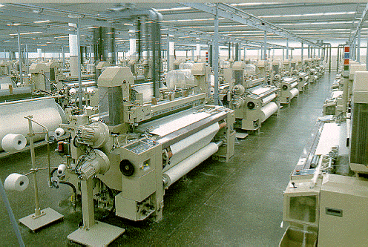
Modern factories with electric machines are much safer for the workers than the old machines powered by steam engines and belts.

Electric Lights (1860-1900): Exploration

For about 50 years electricity was only used in factories.
Nobody thought they needed electricity in their houses until the invention of the light bulb.

Clip the 2 wires to the screws by the light bulb.

What happens as you turn the crank?

Electric Lights (1860-1900): Discussion

What happens when you turn the crank fast?

What happens when you turn the crank slowly?

How did the electric light bulb change the way people lived?

Why must you never allow the two bare ends of the wires to touch each other?

You will not need the generator any more. Put it away.

In 1841 Frederik de Moleyns made the first light bulb. Thomas Edison improved the bulb and made a generator and "power grid." He put electric light bulbs at Pearl Street Station in New York City in 1882. This was one of his huge generators.

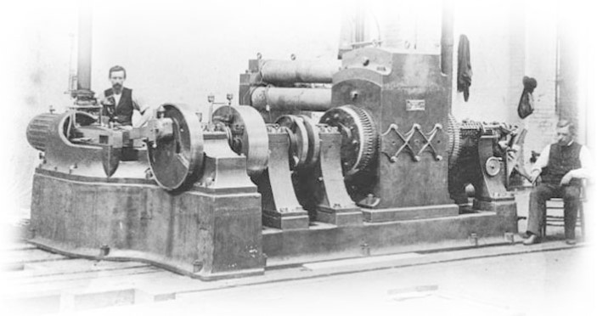

This sign helped people learn how to use the new light bulbs.

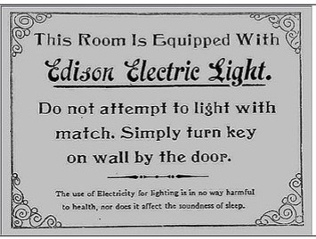

New Skills for Electricity (1865-today): Exploration

There are a few things you need to know before you can get started hooking up your grid.

Your teacher will show you how to cut and strip wires.

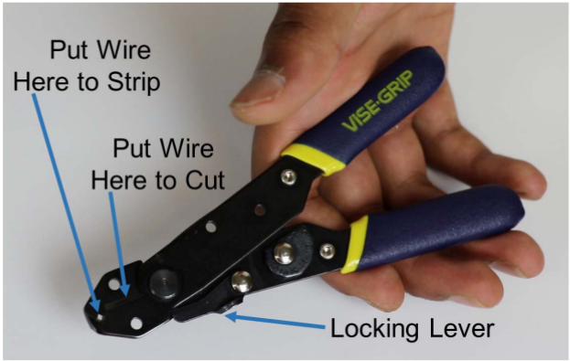

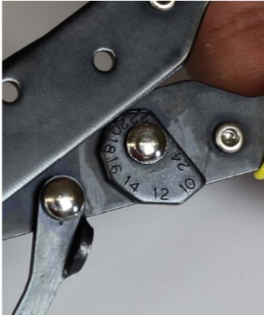
Your wire tool might look like this:

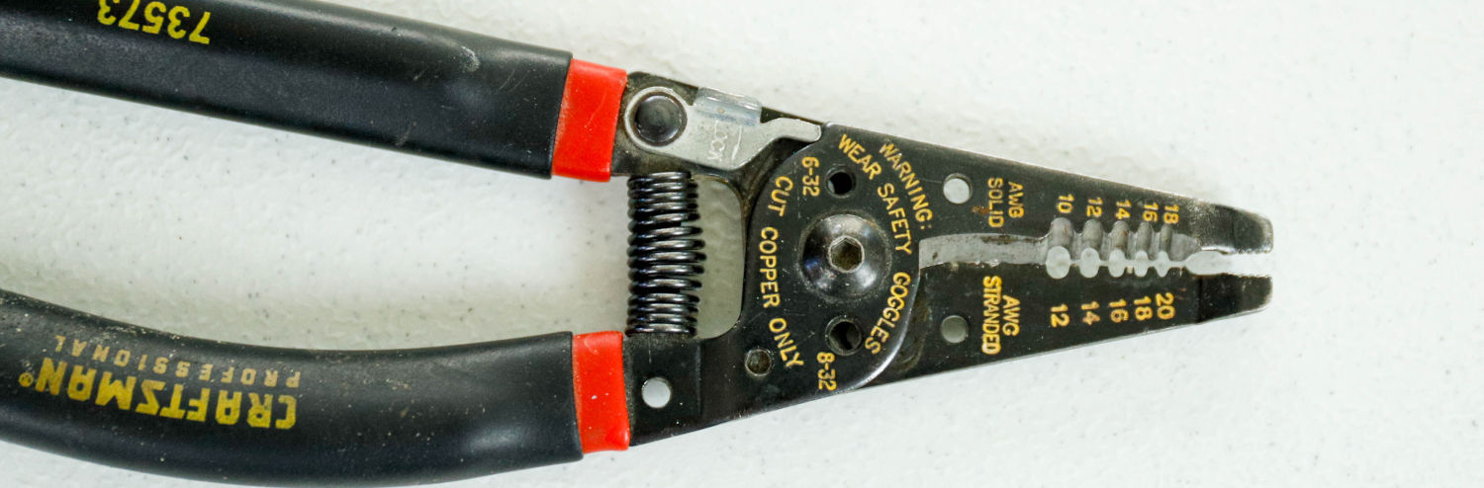

Use this notch to strip the wire.
Cut here.

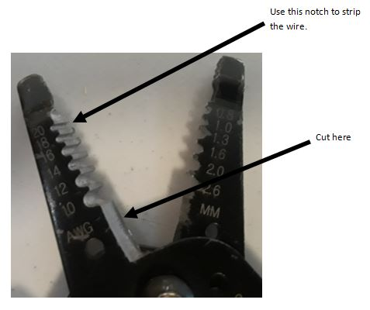

The color of the wire is important. Red, black, and blue wires connect to springs. White wires connect to alligator clips.

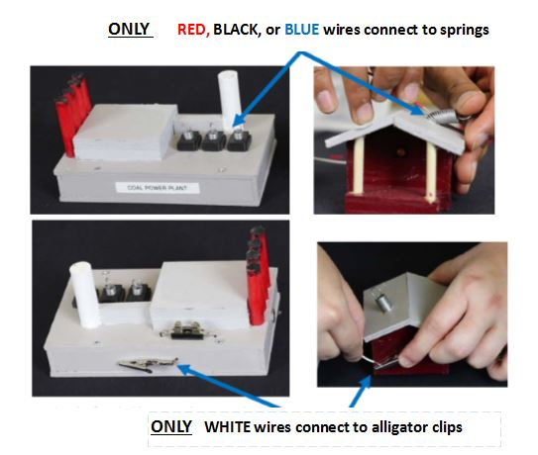

To connect wires, push the spring to the side or pull it down. Stick the bare end of the wire into the spring.

New Skills for Electricity (1865-today): Discussion

Show your teacher how to cut a wire.

Show your teacher that you can strip the plastic insulation off a wire.

Why is it so important to use the right color of wire?

Electricity to Your House (1900-1920): Exploration

Pick a power plant and put a red, black, or blue wire on one of the springs.

Pick a house. Put the other end of the colored wire in the spring.
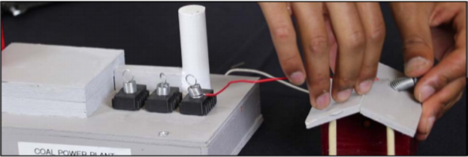

Pinch a white wire in the alligator clip on the power plant. Pinch the other end of the wire in the alligator clip of the house.

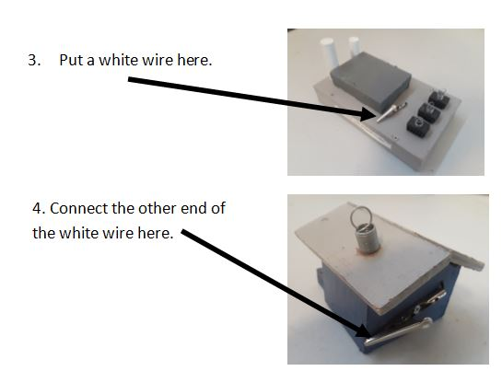

Your teacher will check it and turn on the power.

Did your home get power?

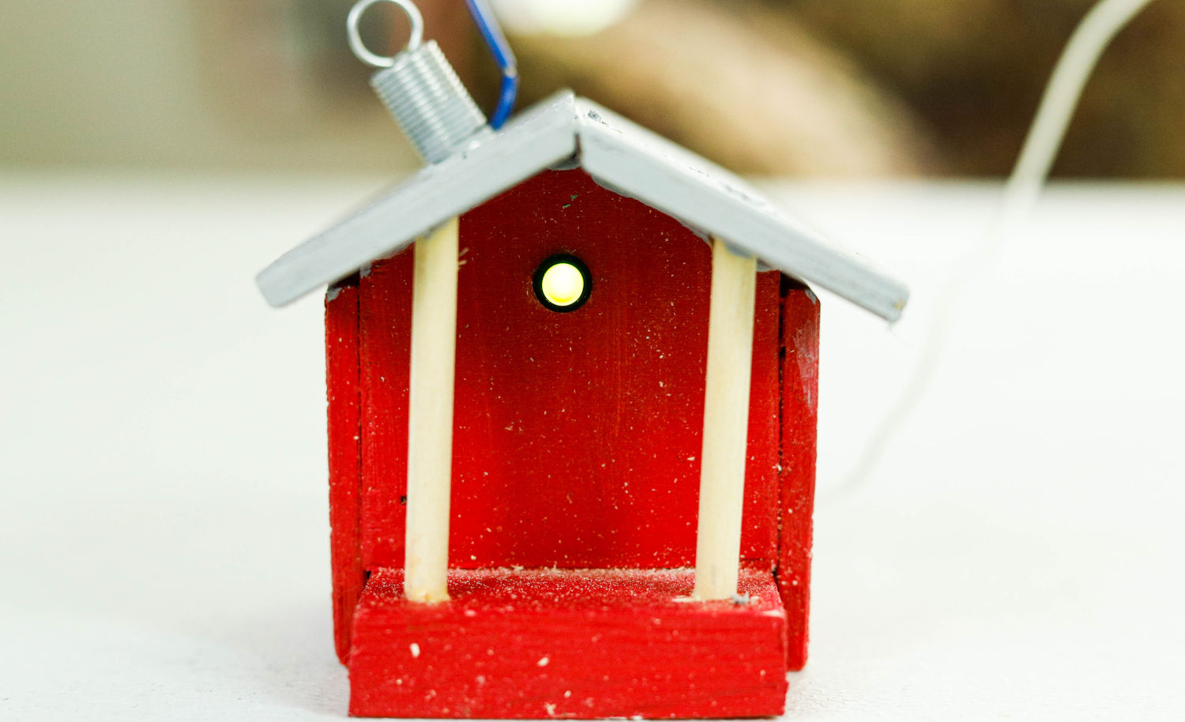

Electricity to Your House (1900-1920): Discussion

What type of power plant did you use?
• Natural Gas
• Coal
• Nuclear
• Renewable (Wind or Solar)

Have you seen a wind farm? If so, where have you seen it?

What is the best kind of power plant?

One Power Plant, Many Houses (1920-1940): Exploration

Unplug the cable from the headquarters office.

Connect a colored wire from the spring on the house to the spring on another house.

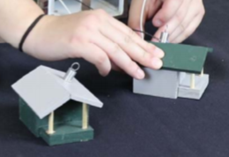
Connect a white wire from one alligator clip to the other.

Call your teacher to check your wires.
Did both homes light up? Why or why not?

Unplug the cable from the headquarters office.
Unplug the colored cable from the power plant spring.
Move the homes away from the power plant and place a low voltage pole between them.
Connect all the wires you need to—colored wires from spring-to-spring and white wires from alligator clip to alligator clip.

Call your teacher to check your wires.
Did both homes still light up? Why or why not?

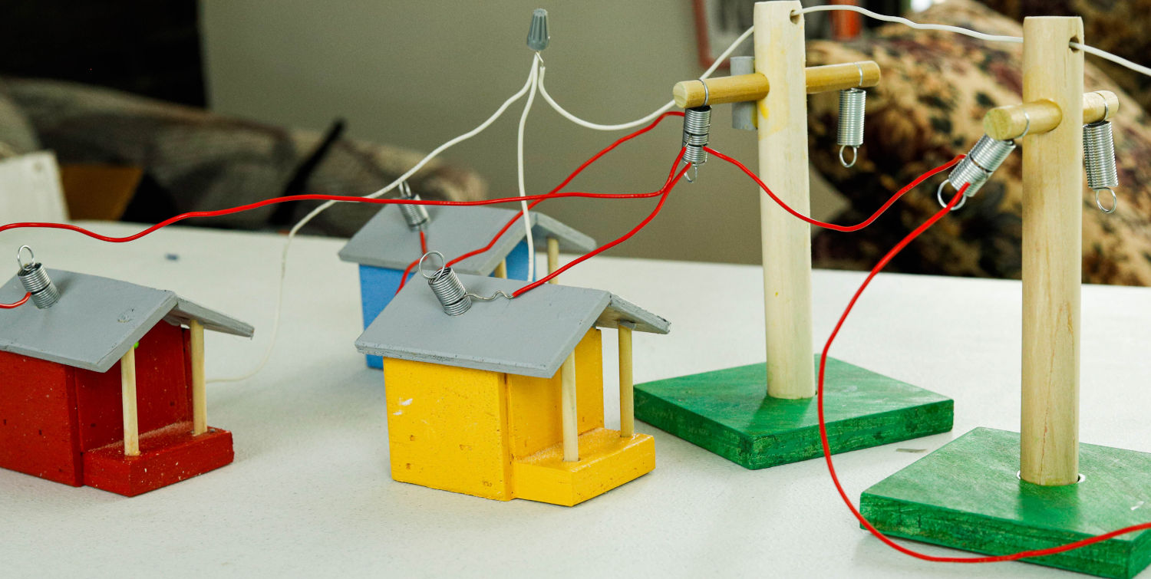

One Power Plant, Many Houses (1920-1940): Discussion

Have you ever lost electricity at your house? Did the whole neighborhood go dark? Why?

Why does every house not have their own generator?

Thomas Edison, Frank Sprague, George Westinghouse and Nicola Tesla were all inventors. They figured out how to get electricity to your house.

High Voltage (1886-today): Exploration

Unhook all of your wires.

Put the power plant at one end of your table.

Put your homes at the other end of the table.

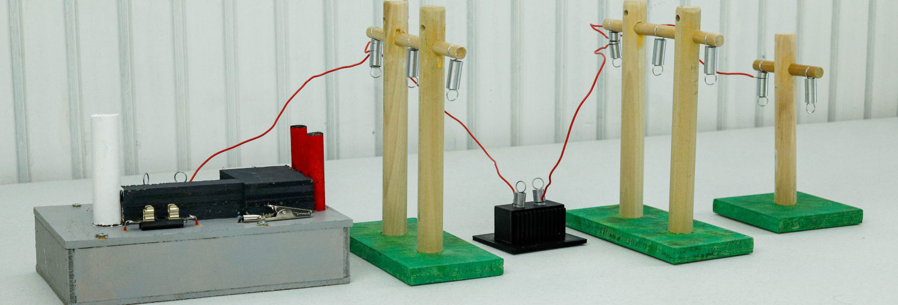

Hook up a colored wire on the tall poles.

Put in a transformer.
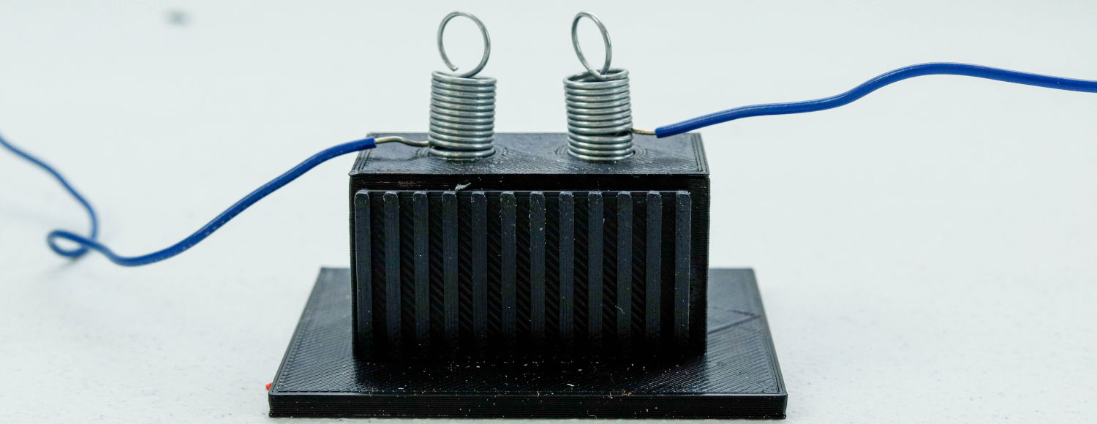

Hook up short poles.

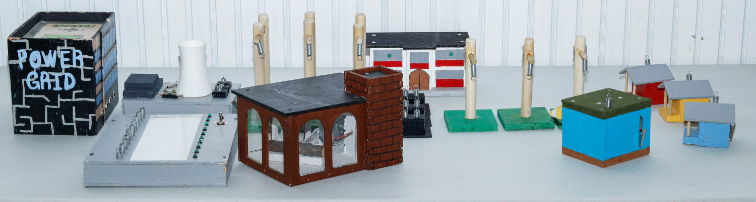

Connect a colored wire from the last pole to your house. The pole closest to the house should have a grey bucket transformer on it.

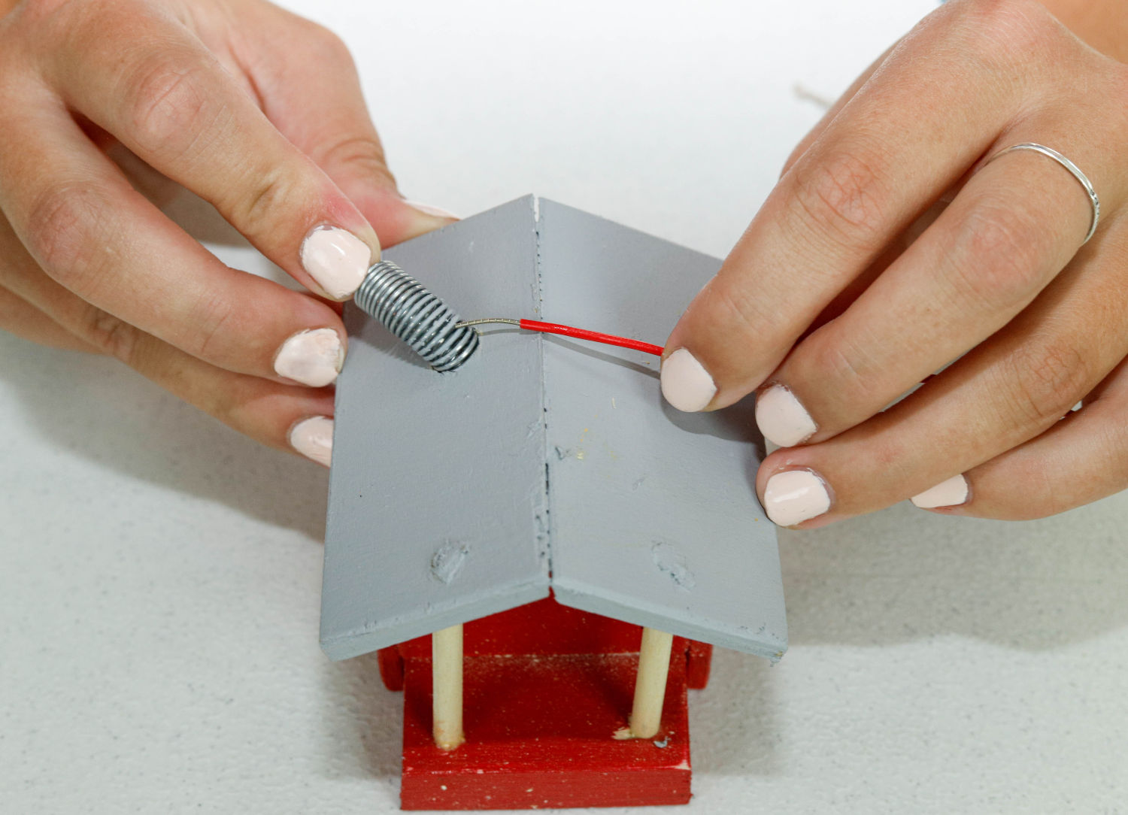

Connect a white wire from your house to the power plant. It goes through the holes in the top of the poles.

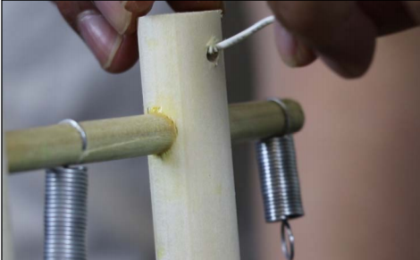

Call your teacher to check it.
Did your homes light up? Why or why not?

High Voltage (1886-today): Discussion

Why did you put in transformers?

Is there a transformer by your house?

Electric companies made long power lines to connect lots of customers. But, long power lines make it hard to find problems.

Monitors (1950-2000): Exploration

Connect a 1/4" audio cable from the headquarters office to your smart grid monitor.

Turn on the switch. A red light should come on.

Connect a gray wire to any spring on your grid.

Connect the other end of the gray wire to the top spring on your monitor.

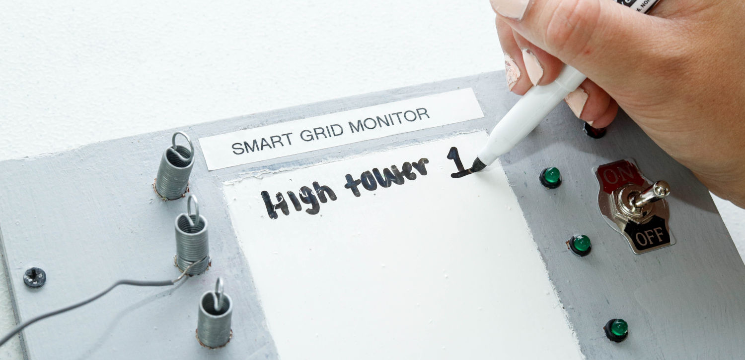

Write the place where the gray wire is attached. Use the dry erase marker.

Monitors (1950-2000): Discussion

What happens when you connect the gray wire to the monitor?

What does the smart grid monitor tell you?

In 1953 American Electric Power built a grid system that connected seven states. This grid allowed companies to share power plants and cover demand if one of them went offline.

Smart Grid (2000-2020): Exploration

Hook up more gray wires to your monitor and grid.

Ask your teacher to take off a wire.

Find the problem using your smart grid monitor.

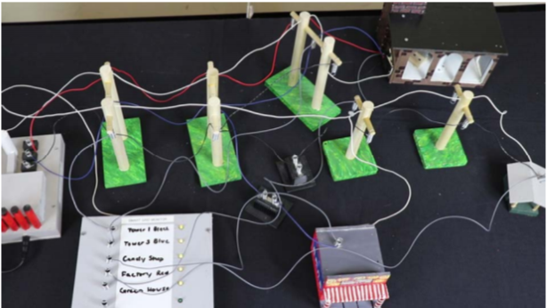

Smart Grid (2000-2020): Discussion

How does a power company know if a customer's home loses power?

With smart meters, how does the power company know if a customer's power goes off?

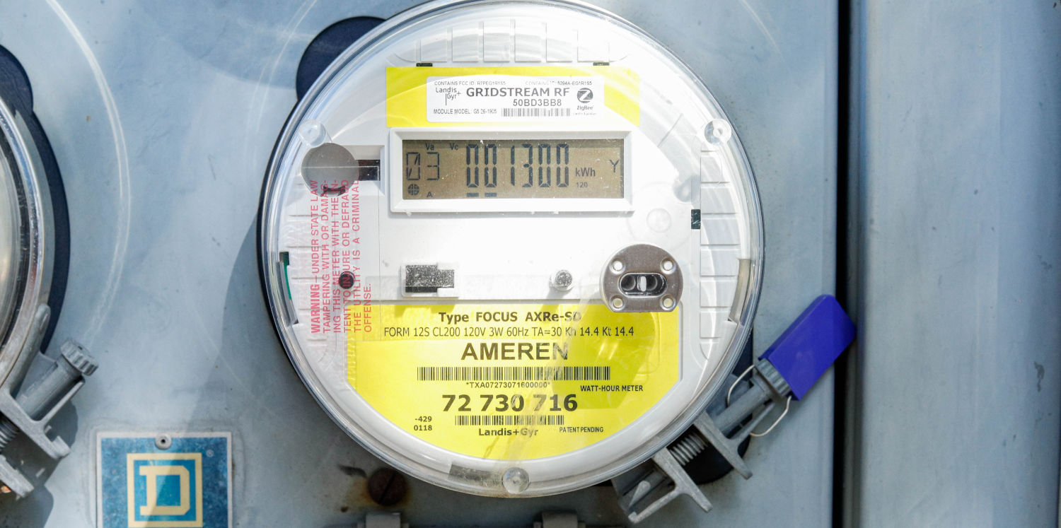

Follow-Up Discussion Questions

What did you like about making the electrical grid?

Remember, power is important but it can be unsafe. NEVER play around electrical wires inside or outside your home.

Draw a picture of your school with a wind turbine or solar panels. What would it take for it to work?

How could you save electricity at your home or school?

If everyone were driving electric cars in 10 years, how does the grid have to change?

