Take the box out of the garage and unpack it. Put the car and water sensor to the side.
Plug the multi sensor into a black adapter. Then plug it into a smaller outlet on the back of the house.
Plug the home into the wall.

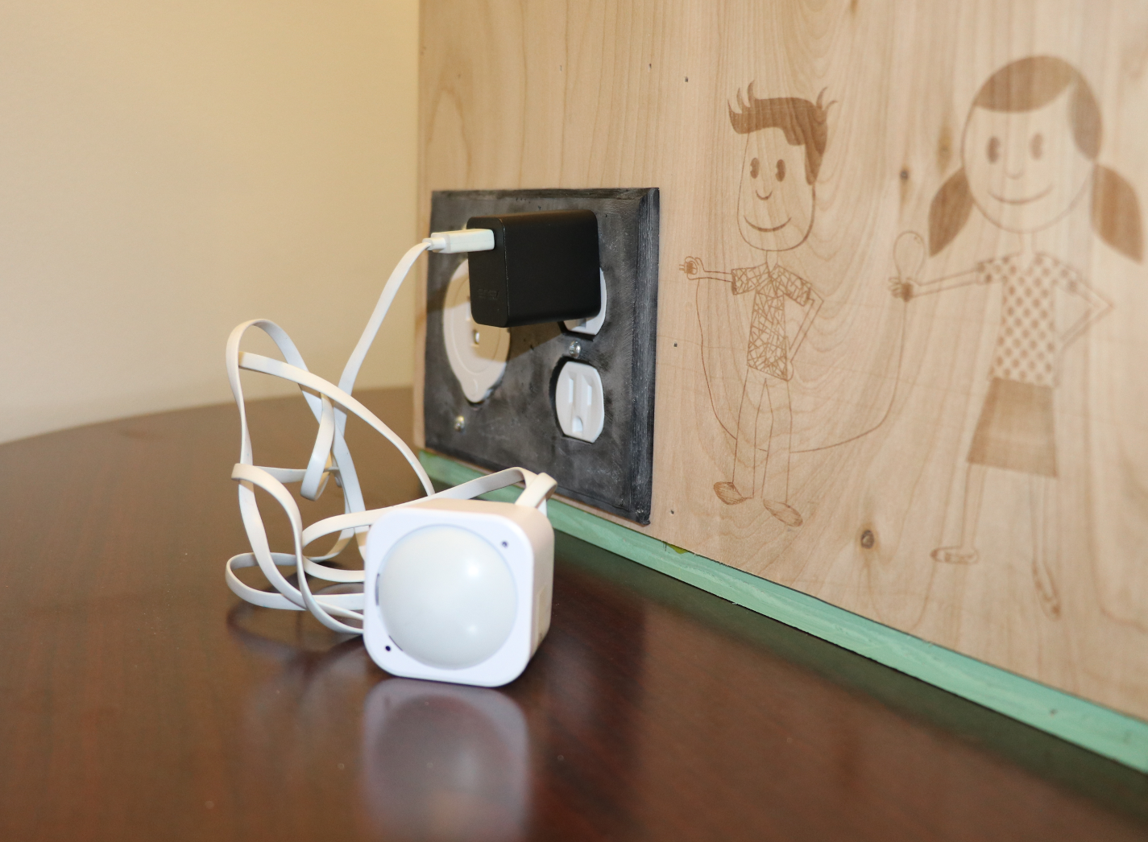

To open the roof, turn the two metal hasps. Then lift the metal straps.

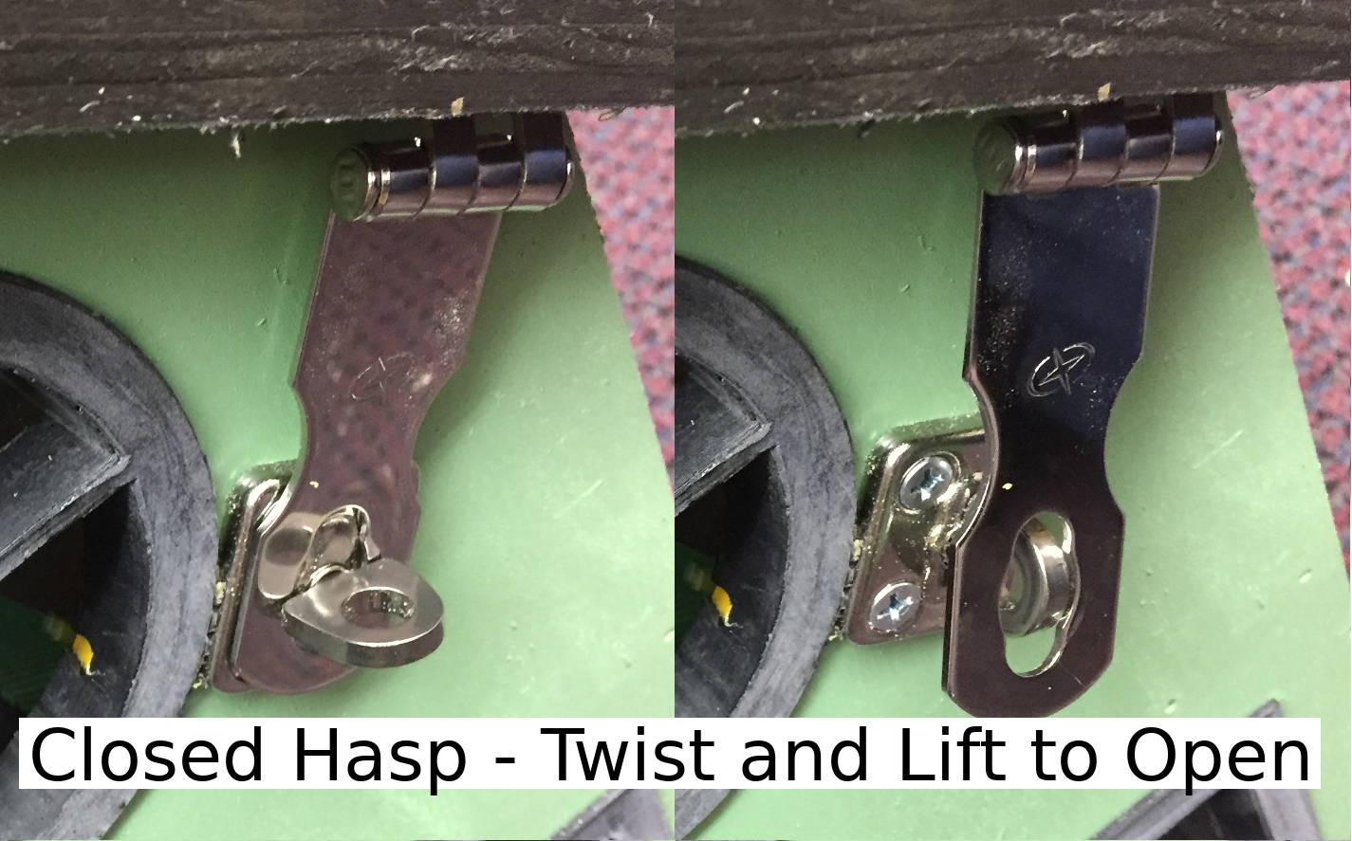
Loosen the strap that holds the tablet. Turn on the tablet.
A phone or tablet is used to control most home automation systems.
The power button is on the side. It looks like a circle. Press and hold the power button for 5 seconds, then let it go. Keep doing this until it turns on.
If the tablet does not turn on, plug the cord into the tablet. Wait 5 minutes before you turn it on.

Your tablet will show one of three screens after you swipe up:
Option 1) The smart home interface. This is a web page in the Chrome browser. If you are on a different page, type the address (http://192.168.1.2/) into the address bar. Press Go.
Option 2) The Android menu screen. Open the Chrome browser. If you are on a different page, type the address (http://192.168.1.2) into the address bar. Press Go.

Option 3) The grid construction game. This is a web page in the Chrome browser. Click the home icon to go to the smart home.

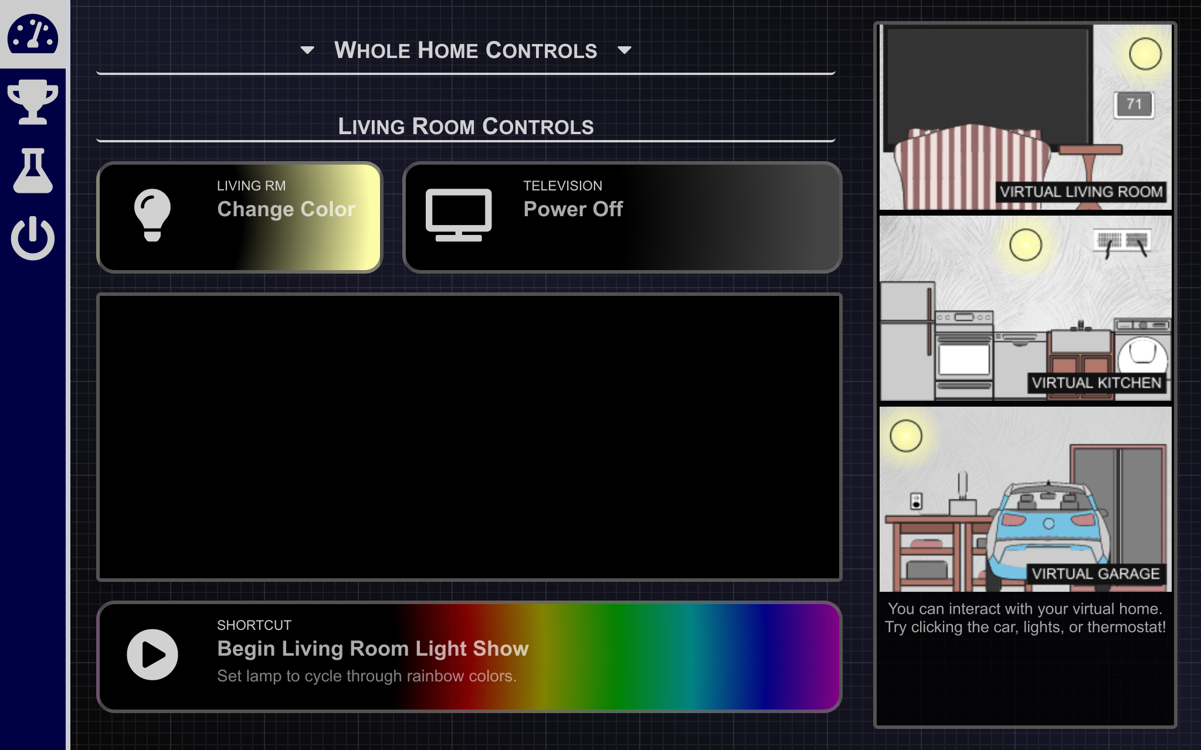 | 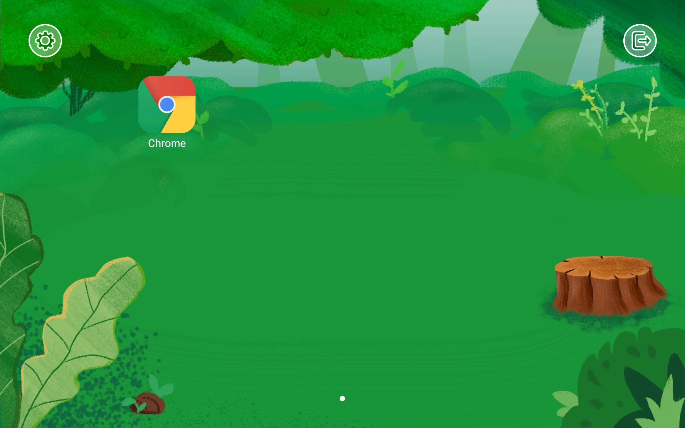 | 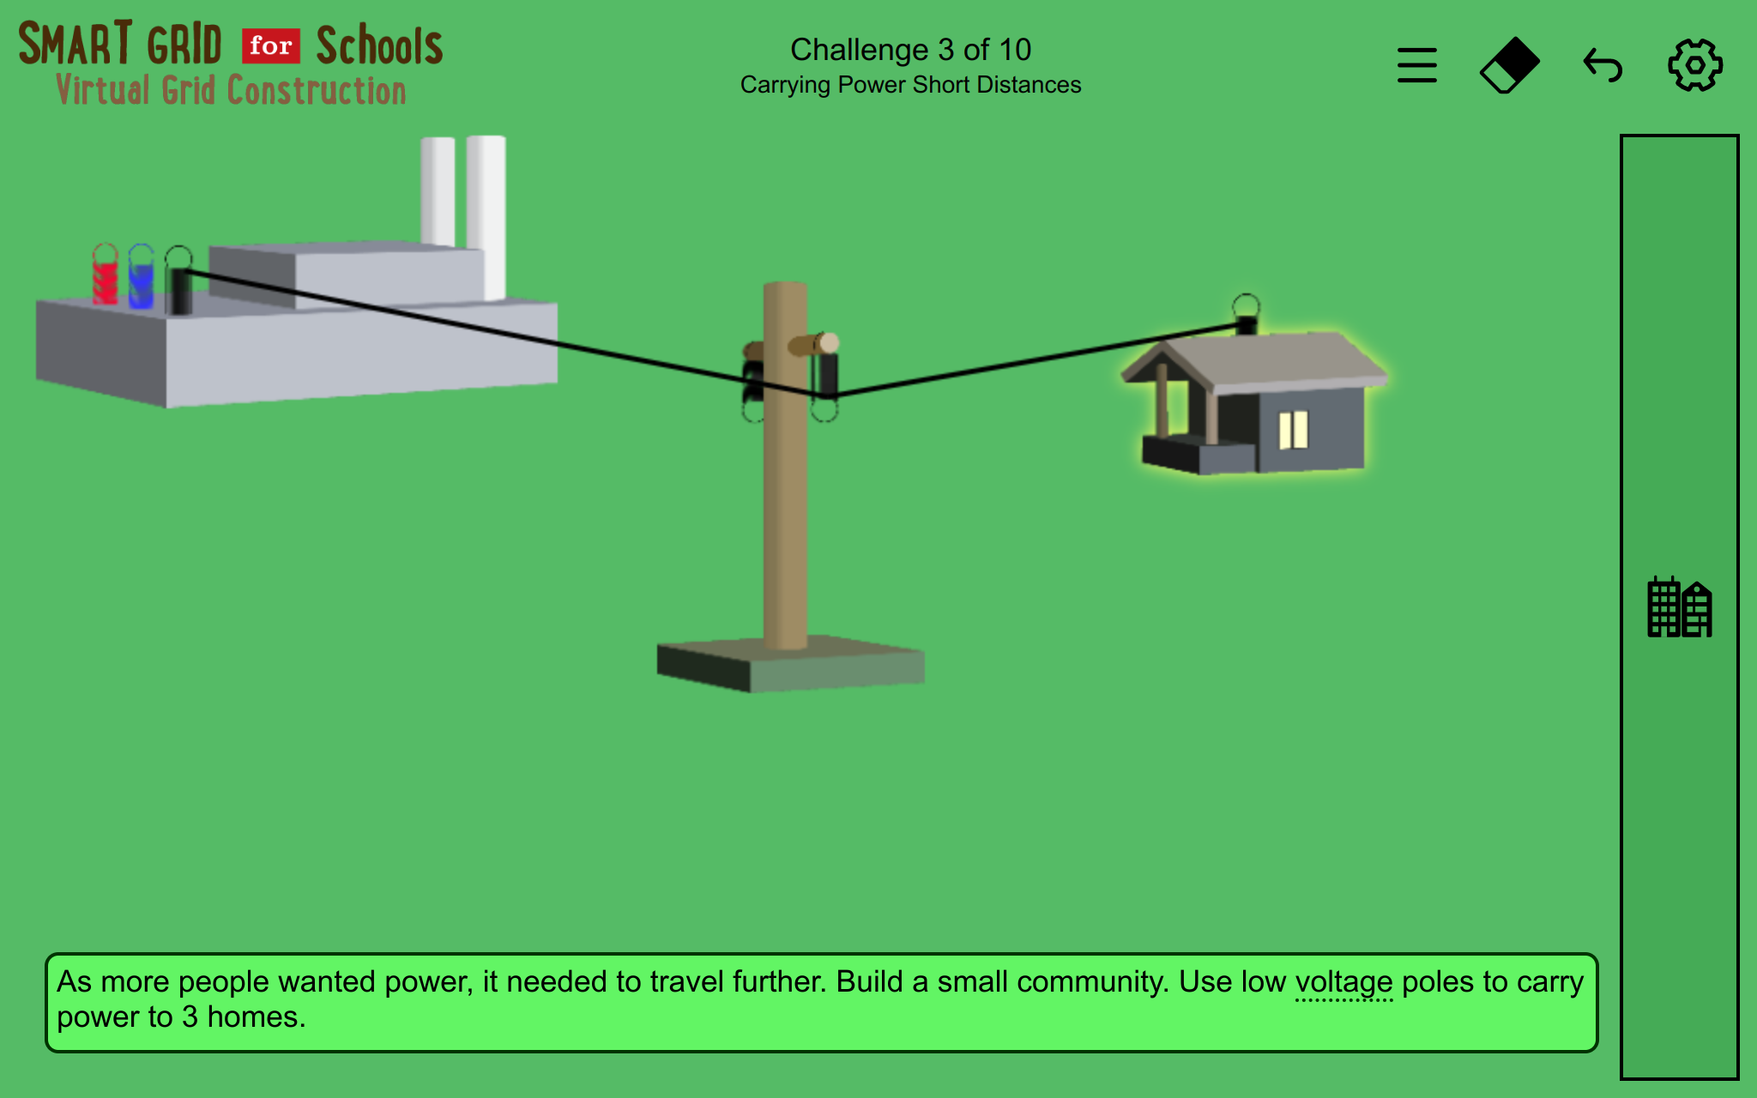

Make sure you are on the home page.

Explore this page. Tap icons to control the home. You can click on rounded buttons and items in the virtual home. Square buttons may not let you click them.
When you are finished exploring, answer the questions below.

Which controls on this page do you like the best? Why?

Go to the Challenges page.
For each challenge, follow the on-screen prompts. Many of the challenges have multiple parts, so continue through each part until you see the completion notification at the bottom of the screen. You may need to scroll to see new information which has appeared below the bottom of the page.

How much energy can you save with a new bulb?
Complete the activities on screen. Before you click the check mark, answer the questions below.

Look at the 15-Year Energy Cost. Which bulb is cheapest? Why do you think each bulb's cost is so different?

Use subtraction to see how much money you can save. What is the difference between the 1-year cost of an LED and the 1-year cost of an incandescent?

How much money can you save as the seasons change?
Complete the activities on screen. Before you click the check mark, answer the questions below.

Why should you keep your house cooler when it is cold outside? Why should you keep your house warmer when it is hot outside?

How much energy can you save by upgrading your appliances?
Complete the activities on screen. Before you click the check mark, answer the questions below.

Which fridge did you choose? Why did you choose that over the other?

A fridge uses 3600 W in 24 hours, but energy is usually measured in kW. If a kW = 1000 W, how many kW did you use?
Go to the Experiments page.

What can your home do to automatically save energy?
Complete the activities on screen. Before you click the check mark, answer the questions below.

What was the plan you developed for your car's arrival?

Why was this a good plan?

Where do solar cells receive the most light energy?
Complete the activities on screen. Before marking the challenge complete, answer the questions below.
What is lightest area? What is darkest? What evidence have you collected to support that?

How much power can you generate on a windy day?

Complete the activities on screen. Before marking the challenge complete, answer the questions below.
What happens when there is not enough wind? Too much wind?

Where do you get your electricity if there is no power coming from the turbine?

How many phone chargers are plugged in at your house? How much wind do you need to charge them all at the same time?

If the wind is blowing at 12mph, your turbine can power 1 laptop computer or 10 phones. Why do you think the laptop uses more power?

You explored different parts of a smart home. How can a smart home help you use less energy?

Shutting the System Down
Please do not unplug the home without turning it off first. This could damage the computer inside the home. You can turn the home off from the tablet's Admin menu (power icon).

Please power the tablet off also. Press and hold the power button on the side, then press Shut Down on screen. Please leave the tablet plugged in to charge.

