Everything done by humans requires energy. Making things and moving things take energy. Heating food and charging your phone take energy. What would you do without power at home or school? Modern society relies on energy!

Muscles did most work until recent times. Humans and animals tire easily, though. At the end of the Roman era, Europeans learned to use waterwheels. They could crush grain, saw wood, and more. 1,200 years later, the Dutch used wind power to do many of the same things. Wind and water are hard to predict, though!

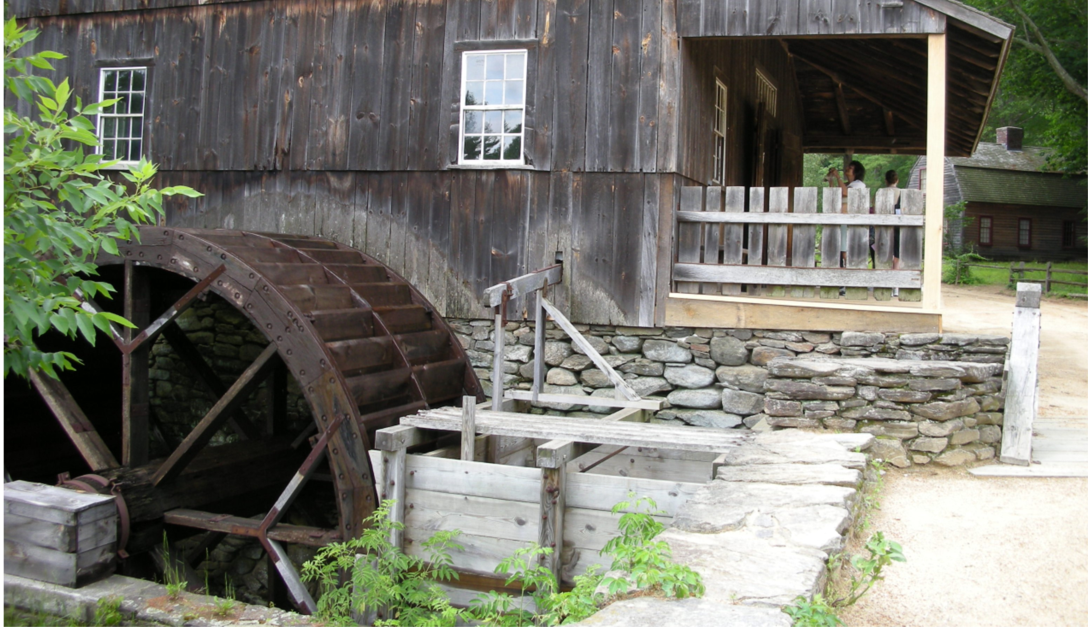
Image Source: Sakuramochi

James Watt patented the modern steam engine in 1769. Steam engines could run all the time, but their belts ran all the time too. This made factories dangerous. Look at the textile factory below. You can see the shafts, belts, and pulleys which transferred power from a steam generator.

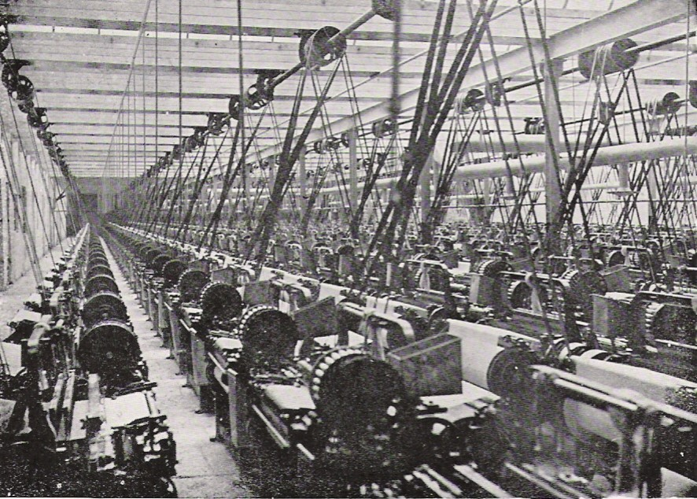
Image Source: History of Massachusetts

By 1831, Michael Faraday knew how magnetism and electricity worked together. A steam engine's motion could move a magnet. As the magnet moved, it could generate electrical energy.

One of the first uses of electricity was the motor, developed by Moritz Jacobi in 1834. An electric motor only needs two wires. This is much safer than long shafts and belts. Many factories built their own power plants.

Access the grid construction game at https://gridconstruction.smartgridforall.org/.

Complete Challenge 1: Connecting Power Plants to Factories.
Why do you think your first power plant was a coal power plant?

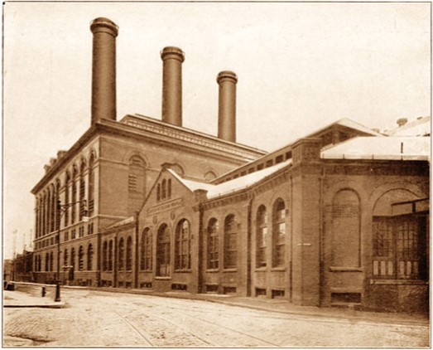
Image Source: The New York Times

The power plant above is Thomas Edison’s Pearl Street Station. It is a coal plant and looks similar to coal plants today.

This game prevents a lot of problems which exist in the real world. Wires only connect between springs of matching colors. What could happen if you mismatched wires?

Complete Challenge 2: Adding Nearby Customers.
This game also hides ground/neutral wires. In the real world, these connections make electricity safer. Power in your home is grounded in three ways. First, a grounding rod pushes into the earth. Next, a ground wire connects back to the substation or power plant. Last, a ground wire connects to a cold water line. Each of these is a safer path than through a person!

Complete Challenge 3: Carrying Power Short Distances.

In the last challenge, you connected homes to a power plant or factory. How is using distribution poles better?

How difficult was it to find the downed wire at the end of the challenge?

Picture the city you live in. It probably has more than 3 homes. How much more difficult would it be to track downed lines there?

The game references a 1-mile limit for power lines. This was true of the DC (direct current) electricity used by Pearl Street Station. It provided power to one square-mile area of New York City in 1882. It mainly served rich customers like the New York Stock Exchange.

Complete Challenge 4: Using Transformers to Carry Power Long Distances.

You can think of voltage as the size of the pipe carrying electricity. The bigger the voltage, the more energy can flow. What could happen if a high-voltage wire went to a low-voltage device?

Today we use AC (alternating current). It could travel much further than DC, but it had a problem. Low-voltage AC lines lose a lot of power! This problem was overcome by George Westinghouse and Nicola Tesla. They used Michael Faraday’s research on voltage to make transformers. Transformers at power plants and in your neighborhood raise or lower voltage. High voltage travels well, but customers need low voltage.

All power lines are dangerous, but high voltage lines are more dangerous. The taller the distribution pole, the higher the voltage that the line carries. This is true even in the substation pictured on the next page. In this station, you can see transformer fins on vertical rods. In the game, fins are horizontal along black boxes.

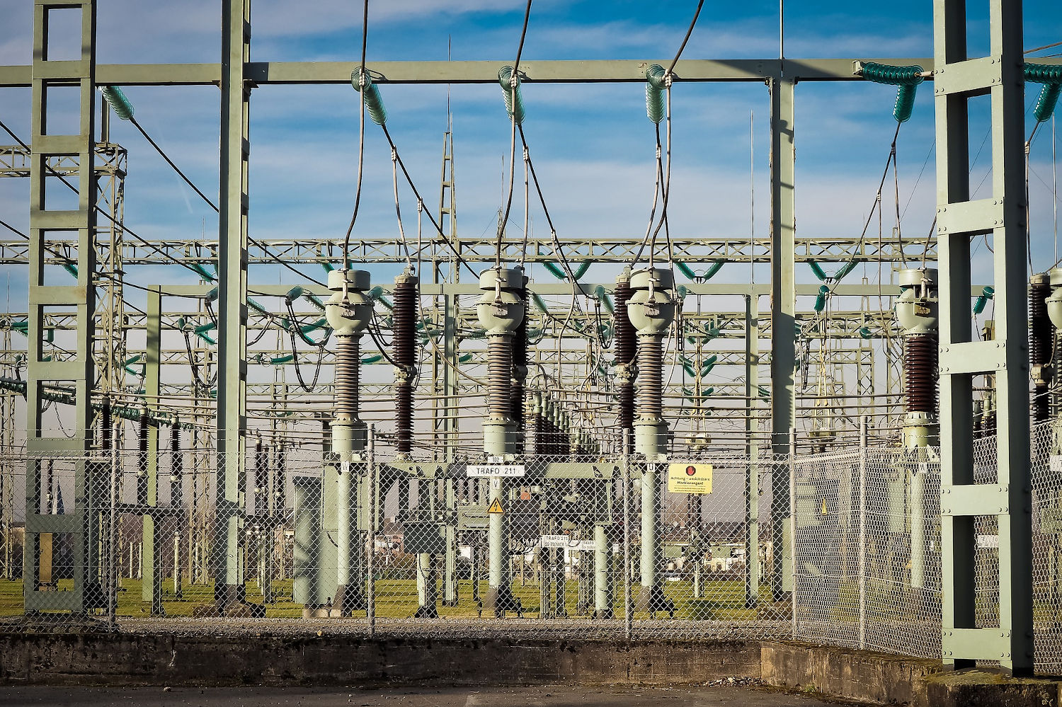
Image Source: Michael Gaida

Complete Challenge 5: Providing 3-phase Power to Large Customers.
All power plants produce 3-phase AC power. As a generator spins, power alternates from positive to negative. With three phases, there is always a nearly-positive and a nearly-negative phase. This provides more, smoother power for customers like factories. (When you ride your bike, you are using 2-phase power. When you lift one leg, the other leg is pushing down, so one leg is always providing energy.)

Click the city icon to look at all the buildings. The third column has 3-phase customers. The fourth column has single-phase customers. Do any of the buildings in each category surprise you? Why or why not?

Complete Challenge 6: Bringing Power to a Large Community. In this challenge you have access to most of the buildings in the game, including multiple power plants.

Is it bad to have more than one power plant?

In this challenge, you experienced two different storms. First, a storm took down a single line. Compare this experience to Challenges 3 and 5. Is it easier or harder to find downed wires as your city gets larger? Why?

In the second storm, two lines were pulled down. How did losing two lines make solving the problem more difficult?

Complete Challenge 7: Adding Smart Meters.

What information do smart meters give power companies during storms? Why is this information important?

Complete Challenge 8: Balancing Loads.

The power at your home is alternating current (AC). It cycles between positive and negative exactly 60 times per second. Power companies closely monitor this rate. If the frequency drops to 59.999, companies increase production. If it increases to 60.001, they reduce production.

Power companies will always need to monitor frequency. They must ensure the right amount of power is running through power lines. Smart meters give companies more information and give them new options. To balance loads, companies can increase production at one power plant or reduce production at another. They can also use switches to direct extra power from one neighborhood to another which needs it.

What is an advantage of coal or natural gas plants in load balancing?

Power companies are exploring large-scale batteries to help balance loads. Batteries could store extra energy when the frequency rises and release energy when it drops. What two power plants in this game would work best when paired with batteries? Why?

Complete Challenge 9: Adding Switches for Redundancy.

What does a switch do?

Why would the job of line workers be impossible without switches? (Line workers repair lines, repair equipment, or connecting customers.)

Switches are often alongside transformers. In this case, they came just after the power plant's transformers. Redraw the map below. How could you move the switches but still control which plant provided power?

Complete Challenge 10: Automating the System.

Completion of Challenge 10 requires you to restore power in 0 minutes. A light might flicker, but in most cases customers would not even notice that! How were you able to use smart meters and switches to make this happen?

You have now worked with a variety of grids. You have seen several examples of more complex grid systems. Anything you’ve seen on-screen is still a simple likeness of the actual grid. Although the grid is complex, it is based on 100-year-old technology. If Edison, Tesla, and Westinghouse were alive today, the only piece they wouldn’t recognize is the smart meter! Of course, they might quickly see the value of smart meters, especially in combination with switches. As electric cars become more popular, more energy will need to move more efficiently through the electrical grid.

Play for a while in Free-Play Mode. (This is available after you finish Challenge 10.)

What about this game is realistic?

How might this game be different from how power works in the real world?

