Nearly everything done by humans requires energy. Making things and moving things take energy. Heating food and charging your cell phone also take energy. What would you do without electricity at home or school? Modern society relies on energy!

Nearly all work was done with muscle power until recent times. Both humans and animals have limited power and get tired easily. At the end of the Roman era, Europeans learned to use waterwheels. They were able to crush grain, saw wood, and do many more tasks. 1,200 years later, the Dutch used the power of wind to do many of the same tasks. Wind and water are hard to predict, though!

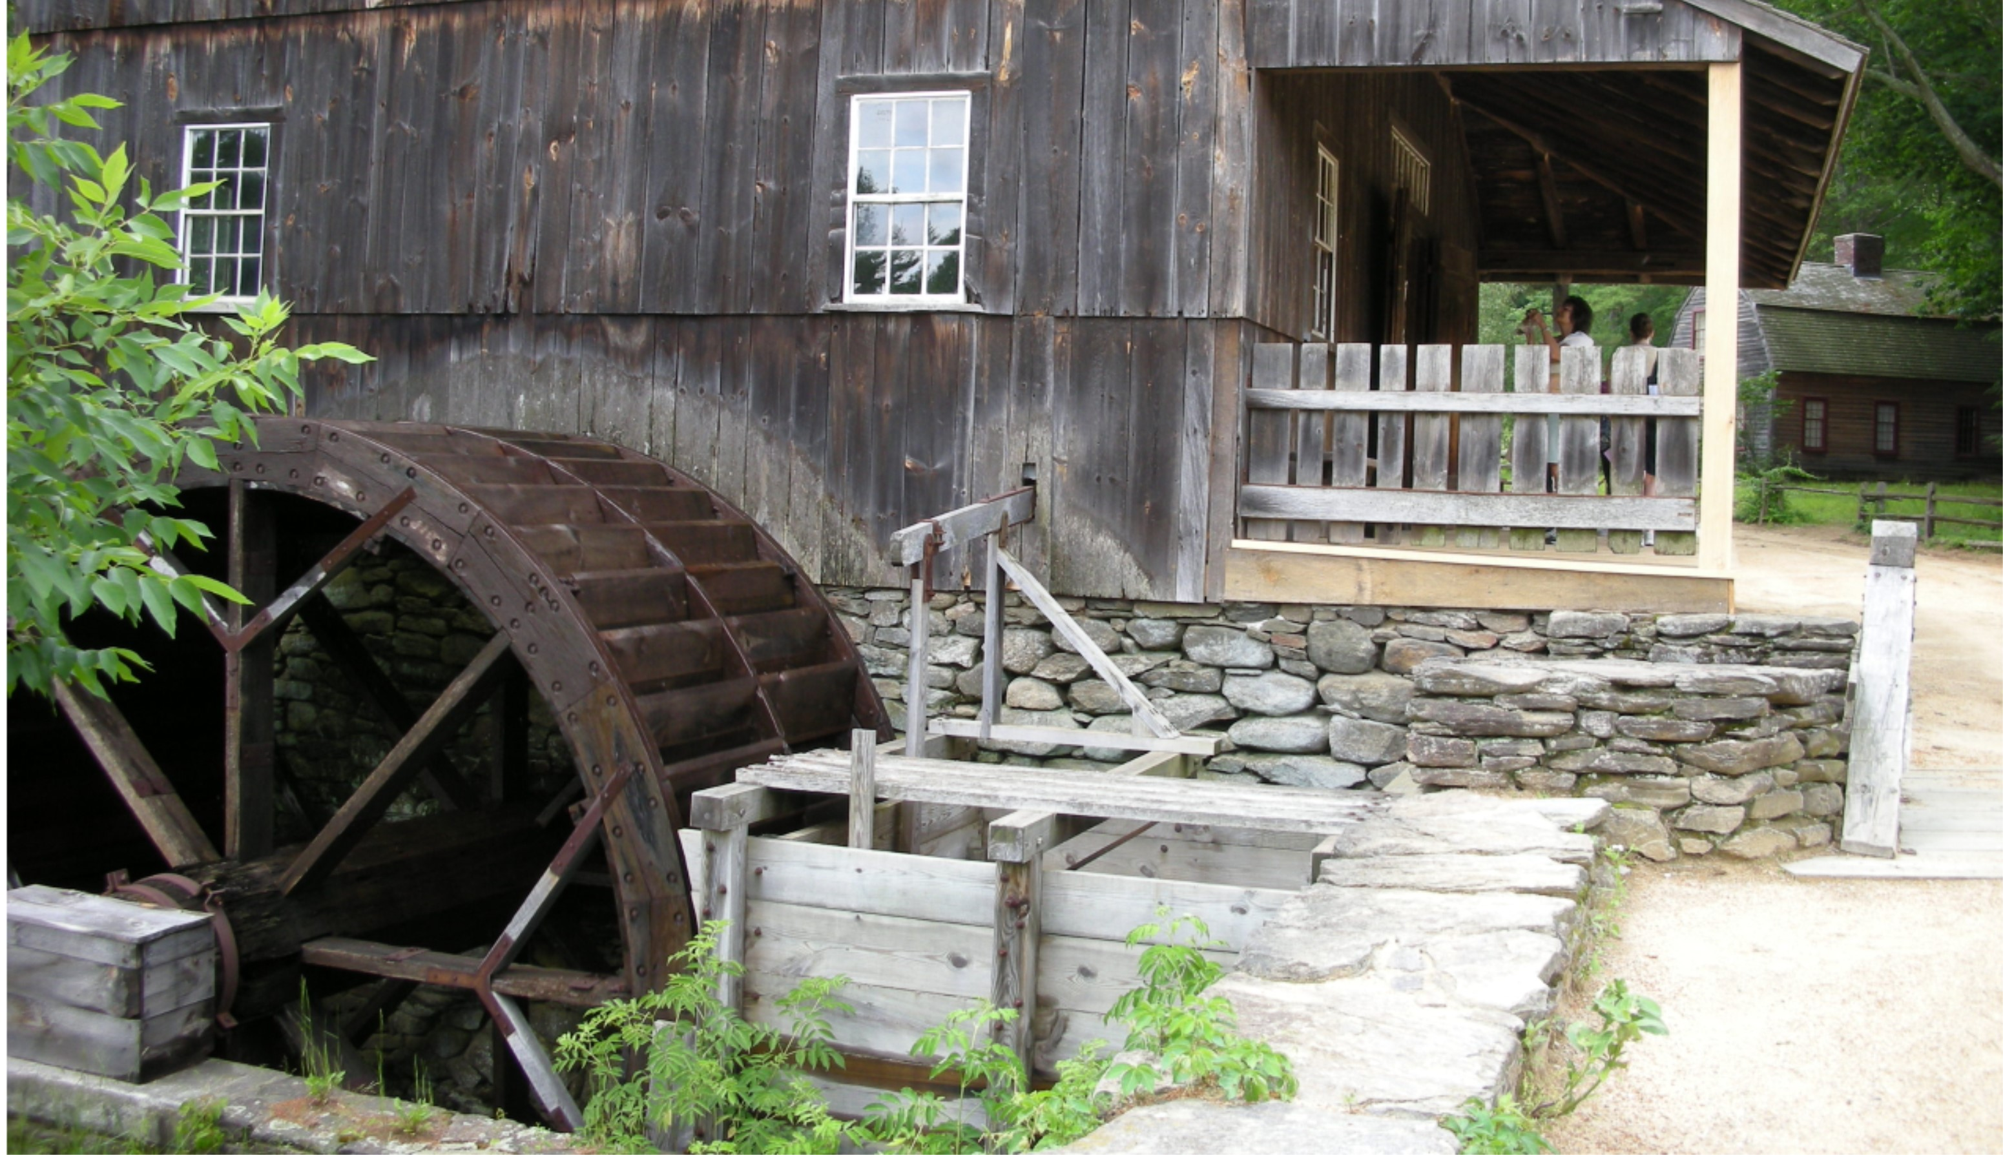
Image Source: Sakuramochi

James Watt patented the modern steam engine in 1769. Steam engines could be run all the time, but their belts ran all the time too. This made factories dangerous. Look at the textile factory below. You can see the shafts, belts, and pulleys which transferred power from a steam generator.

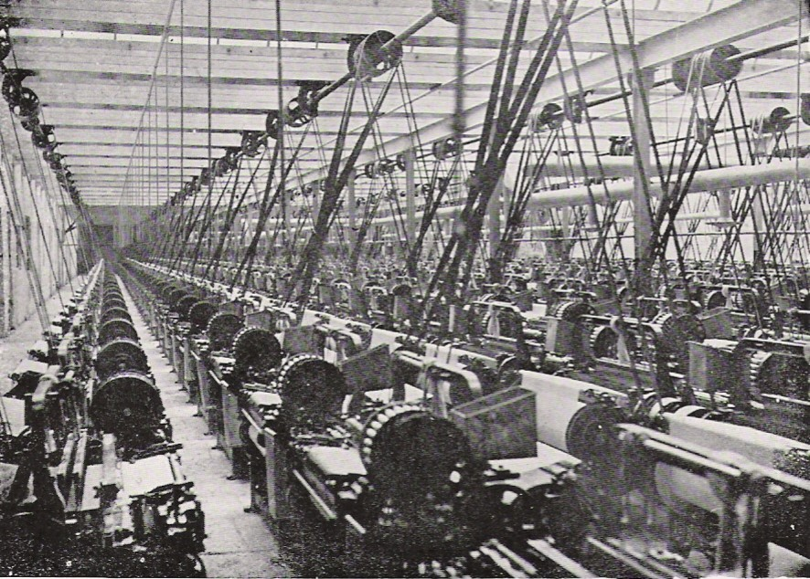
Image Source: History of Massachusetts

By 1831, Michael Faraday understood how magnetism and electricity worked together. A steam engine's motion could move a magnet. As the magnet moved, it could be changed into electrical energy.
One of the first uses of electricity was the electric motor, developed by Moritz Jacobi in 1834. An electric motor only needs two wires. This is much better than long shafts and belts, so many factories built their own power plants next door.

Access the grid construction game at https://cemastprojects.org/SGGC/ or https://gridconstruction.cemastprojects.org/.

Complete Challenge 1: Connecting Power Plants to Factories.
Why do you think your first power plant was a coal power plant?

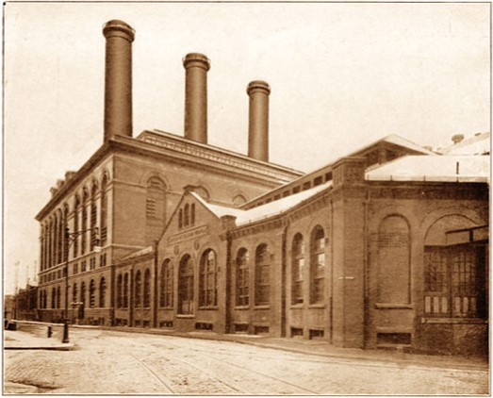
Image Source: The New York Times

The power plant above is Thomas Edison’s Pearl Street Station, a coal plant. It looks similar to coal plants today.

This game prevents a lot of problems which exist in the real world. Wires only connect between springs of matching colors. What might happen if you mismatched wires?

Complete Challenge 2: Adding Nearby Customers.
This game also hides ground/neutral wires. In the real world, ground/neutral connections are needed for safety. Electricity in your home is typically grounded in three ways. First, a grounding rod is pushed into the earth. Next, a ground wire is connected back to the substation or power plant. Last, a ground wire is connected to a cold water line. Each of these is a safer path for electricity than through a person!

Complete Challenge 3: Carrying Power Short Distances.

In the last challenge, you connected homes to a power plant or factory. How is using distribution poles better?

How difficult was it to find the downed wire at the end of the challenge?

Think about the city you live in. It probably has more than 3 homes. How much more difficult would it be to track downed lines there?

The game references a 1-mile limit for power lines. This was true of the DC (direct current) electricity used by Pearl Street Station. It provided power to one square-mile area of New York City in 1882. It mainly served rich customers like the New York Stock Exchange.

Complete Challenge 4: Using Transformers to Carry Power Long Distances.

You can think of voltage as the size of the pipe carrying electricity. The bigger the voltage, the more energy flow. What do you think would happen if you connected a high-voltage wire to a low-voltage device?

Today we use AC (alternating current), which can travel much further than DC. Of course, AC had a problem too. Low-voltage lines lose a lot of electricity. This problem was overcome by George Westinghouse and Nicola Tesla. They applied Michael Faraday’s research on voltage to make transformers. Transformers at power plants and in your neighborhood increase or decrease the voltage of the electricity. High voltage travels well, but customers need low voltage.

All power lines are dangerous, but high voltage lines are more dangerous. The taller the distribution pole, the higher the voltage that the line carries. This is true even in the substation, pictured on the next page. In this station, you can see fins on vertical rods. In the game, fins are horizontal along the black boxes.

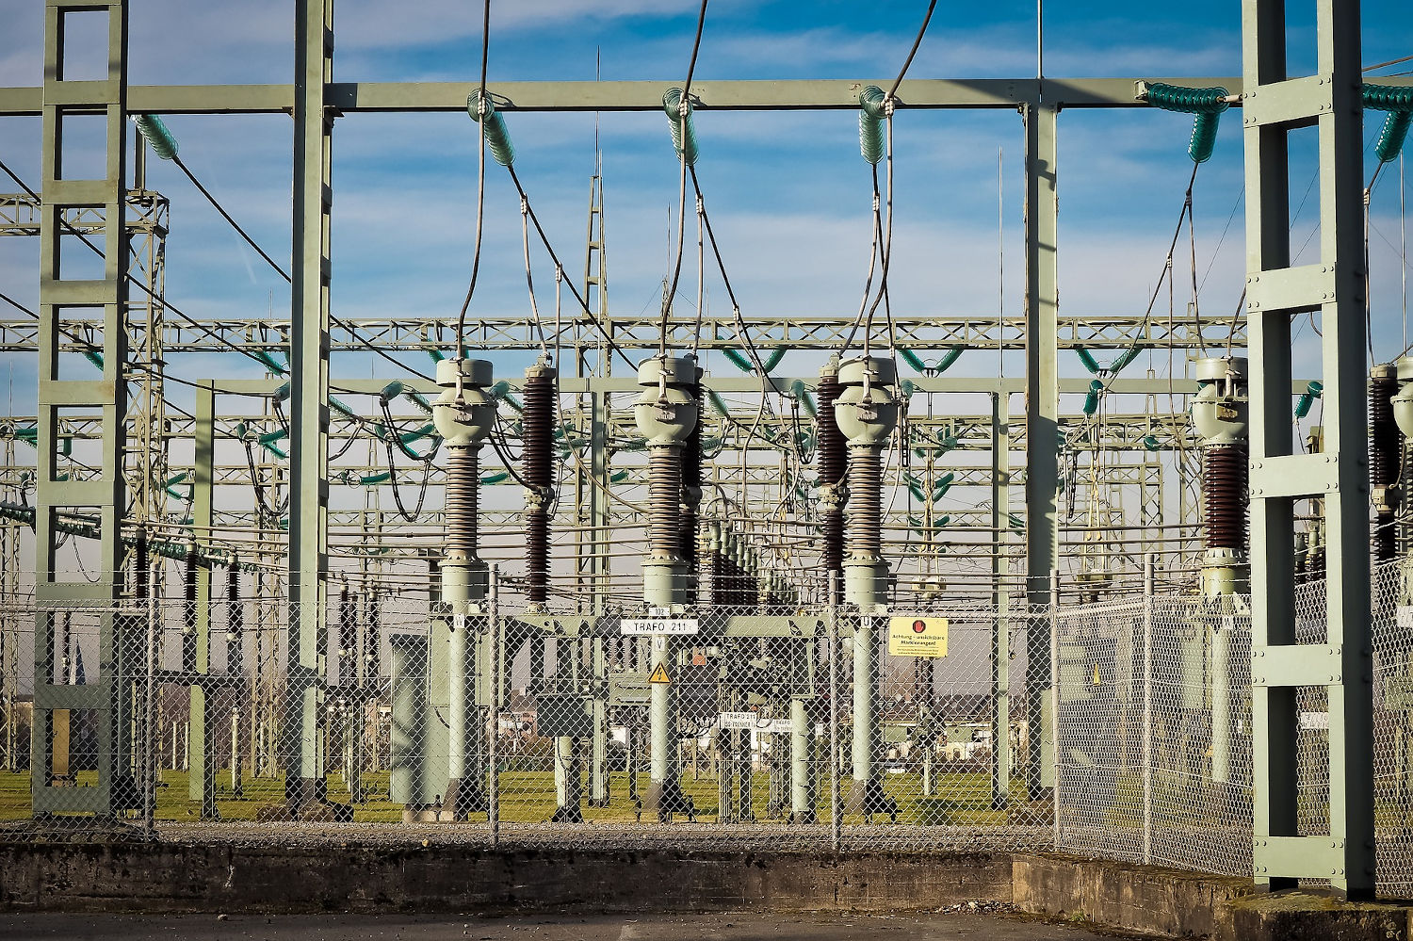
Image Source: Michael Gaida

Complete Challenge 5: Providing 3-phase Power to Large Customers.
All power plants produce 3-phase AC power. As a generator spins, electricity alternates from positive to negative 60 times each second. In 3-phase, there is always a phase which is nearly-positive and a phase which is nearly-negative. This provides more, smoother power for customers like factories. (When you ride your bike, you can think of yourself as using 2-phase power. When you lift one leg, the other leg is pushing down, so one leg is always providing energy.)

Click the city icon to look in the building supply menu. The third column has 3-phase customers, and the fourth column has single-phase customers. Do any of the buildings in each category surprise you? Why or why not?

Complete Challenge 6: Bringing Power to a Large Community. In this challenge you have access to almost all the buildings in the game, including multiple power plants.

Is it bad to have more than one power plant?

In this challenge, you experienced two different storms. First, a single line was disrupted. Compare this experience to Challenges 3 and 5. Is it easier or harder to find downed wires as your city gets larger? Why?

In the second storm, two lines were pulled down. How did losing two lines make solving the problem more difficult?

Complete Challenge 7: Adding Smart Meters.

What important information do smart meters give power companies during storms?

Complete Challenge 8: Balancing Loads.

As we’ve already noted, the power at your home is alternating current (AC). It cycles between positive and negative exactly 60 times per second. Power companies monitor this rate very closely. If the frequency drops to 59.999 times per second, companies know they must increase production. If it increases to 60.001 times per second, they are producing too much power.

Power companies will always need to monitor frequency in order to ensure the right amount of power is always running through power lines, but the ability of smart meters to tell where power is being used gives companies new options. Rather than increasing production at one power plant or reducing production at another and hoping that keeps the grid steady, power companies can use switches to direct extra power from one neighborhood to another neighborhood which needs it.

Where load balancing is concerned, what is an advantage of coal or natural gas plants?

Power companies are currently exploring utility-scale batteries to help balance loads. Batteries could store extra energy when the frequency rises and release energy when the frequency drops. What two power plants in this game would work best when paired with batteries? Why?

Why would the job of lineworkers be impossible without switches? (Lineworkers repair lines, repair equipment, or connecting customers.)

Complete Challenge 9: Adding Switches for Redundancy.

What does a switch do?

Why would the job of lineworkers be impossible without switches? (Lineworkers repair lines, repair equipment, or connecting customers.)

Switches are often found alongside transformers. In this case, they were placed just after the transformers on the power plants rather than at the substation transformers. Redraw the map below – how would it change if the switches were moved but we still wanted to control which plant provided power?

Complete Challenge 10: Automating the System.

Successful completion of Challenge 10 should include several storms where power is restored in 0 minutes. In each case, a customer might see a light flicker, but in most cases they would not even notice that! How were you able to use smart meters and switches to make this happen?

You have now worked with a variety of grids, and you have seen at least one example of a larger and more complex grid system. Anything you’ve seen on-screen is still a simple representation of the actual grid. Although the grid is complex, it is based on 100-year-old technology. If Edison, Westinghouse, and Tesla were alive today, the only piece they wouldn’t recognize is the smart meter! Of course, they might quickly come to understand the value of smart meters, especially in combination with switches. Especially as electric cars become more popular, more energy will need to move more efficiently through the electrical grid.

Play for a while in Free-Play Mode. (This is accessible after you finish Challenge 10.)

What about this game is realistic?

How might this game be different from how power works in the real world?

